Date: 30/03/26
📊 Final Count:
🟢 Bullish | 13
🔴 Bearish | 139
Total | 152

🟢 BULLISH TRADES --- 13
1 | LICHSGFIN
2 | ONGC
3 | OIL
4 | KALYANKJIL
5 | NATIONALUM
6 | DMART
7 | SAMMAANCAP
8 | OFSS
9 | AUROPHARMA
10 | GLENMARK
11 | COALINDIA
12 | VEDL
13 | HINDALCO
🔴 BEARISH TRADES --- 139
1 | AUBANK
2 | ADANIPORTS
3 | ABCAPITAL
4 | BAJFINANCE
5 | BAJAJFINSV
6 | BANKBARODA
7 | BANKINDIA
8 | COLPAL
9 | CONCOR
10 | DIVISLAB
11 | NYKAA
12 | GMRAIRPORT
13 | GODREJPROP
14 | HDFCAMC
15 | HAVELLS
16 | ICICIPRULI
17 | IDFCFIRSTB
18 | IIFL
19 | IGL
20 | INDUSINDBK
21 | JIOFIN
22 | JUBLFOOD
23 | KFINTECH
24 | KOTAKBANK
25 | LTF
26 | MANAPPURAM
27 | MARUTI
28 | MFSL
29 | POLYCAB
30 | SONACOMS
31 | TRENT
32 | UNOMINDA
33 | UNIONBANK
34 | YESBANK
35 | ADANIENT
36 | ADANIGREEN
37 | BDL
38 | BEL
39 | CYIENT
40 | MAZDOCK
41 | SOLARINDS
42 | BRITANNIA
43 | CGPOWER
44 | GAIL
45 | HDFCLIFE
46 | HAL
47 | IRCTC
48 | LODHA
49 | NBCC
50 | NCC
51 | PGEL
52 | POWERGRID
53 | TATAPOWER
54 | BHEL
55 | RELIANCE
56 | TMPV
57 | TITAN
58 | AMBUJACEM
59 | ASTRAL
60 | IOC
61 | IREDA
62 | INDIGO
63 | NTPC
64 | RECLTD
65 | SHRIRAMFIN
66 | TECHM
67 | ADANIENSOL
68 | ANGELONE
69 | GRASIM
70 | ITC
71 | MANKIND
72 | ALKEM
73 | APOLLOHOSP
74 | BLUESTARCO
75 | CIPLA
76 | COFORGE
77 | DELHIVERY
78 | DIXON
79 | DRREDDY
80 | HEROMOTOCO
81 | HINDZINC
82 | ICICIGI
83 | INDIANB
84 | NAUKRI
85 | INFY
86 | INOXWIND
87 | JSWENERGY
88 | MARICO
89 | MAXHEALTH
90 | NESTLEIND
91 | SUNPHARMA
92 | TCS
93 | INDHOTEL
94 | TORNTPOWER
95 | TIINDIA
96 | UNITDSPR
97 | ABB
98 | GODREJCP
99 | HCLTECH
100 | ICICIBANK
101 | JINDALSTEL
102 | PAGEIND
103 | PIDILITIND
104 | SYNGENE
105 | CAMS
106 | CROMPTON
107 | POWERINDIA
108 | LT
109 | LUPIN
110 | MPHASIS
111 | RBLBANK
112 | SUZLON
113 | APLAPOLLO
114 | BIOCON
115 | MCX
116 | ASHOKLEY
117 | BHARATFORG
118 | CUMMINSIND
119 | FORTIS
120 | JSWSTEEL
121 | SRF
122 | SUPREMEIND
123 | TITAGARH
124 | PHOENIXLTD
125 | VOLTAS
126 | BAJAJ-AUTO
127 | BSE
128 | INDUSTOWER
129 | SIEMENS
130 | TORNTPHARM
131 | VBL
132 | 360ONE
133 | M&M
134 | POLICYBZR
135 | TVSMOTOR
136 | PRESTIGE
137 | DALBHARAT
138 | KEI
139 | NUVAMA

Trade Taken
🟢 BULLISH SIGNAL --- LICHSGFIN

Nifty Bias : 🔴 SHORT — Counter Trend ⚠️
Crossover : 2026-03-25 09:30 (5 days ago)
Pullback : 2026-03-27 15:00
Low ₹504.65 ≤ EMA9(Low) ₹505.71
High ₹506.9 (breakout level)
Confirm : 2026-03-30 09:15 (+2 candle)
Close ₹507.35 > Pullback High ₹506.9 (body breakout)
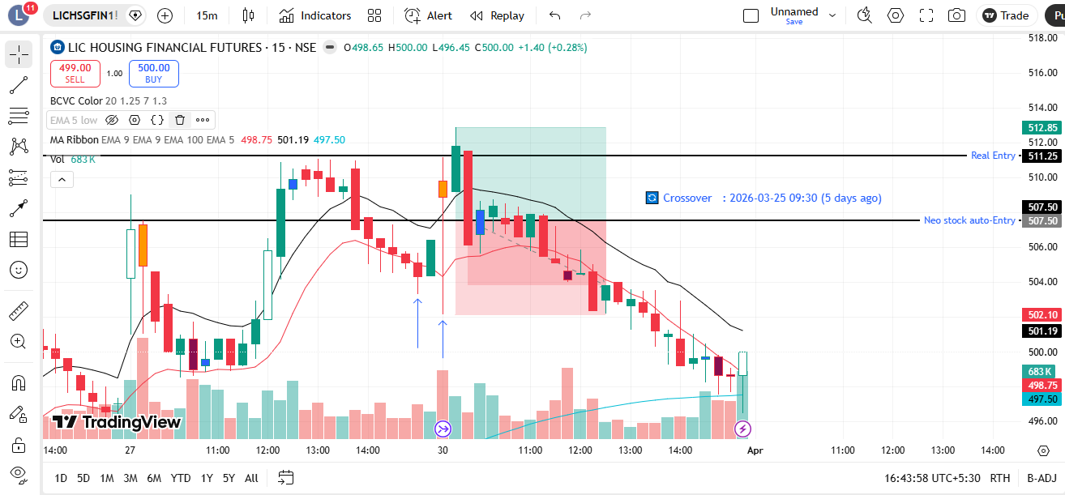
🔴 BEARISH SIGNAL --- ADANIENT

Nifty Bias : 🔴 SHORT — Aligned ✅
Crossover : 2026-03-27 09:45 (3 days ago)
Pullback : 2026-03-30 09:30
High ₹1837.8 ≥ EMA9(High) ₹1830.4
Low ₹1820.4 (breakdown level)
Confirm : 2026-03-30 09:45 (+1 candle)
Close ₹1819 < Pullback Low ₹1820.4 (body breakdown)
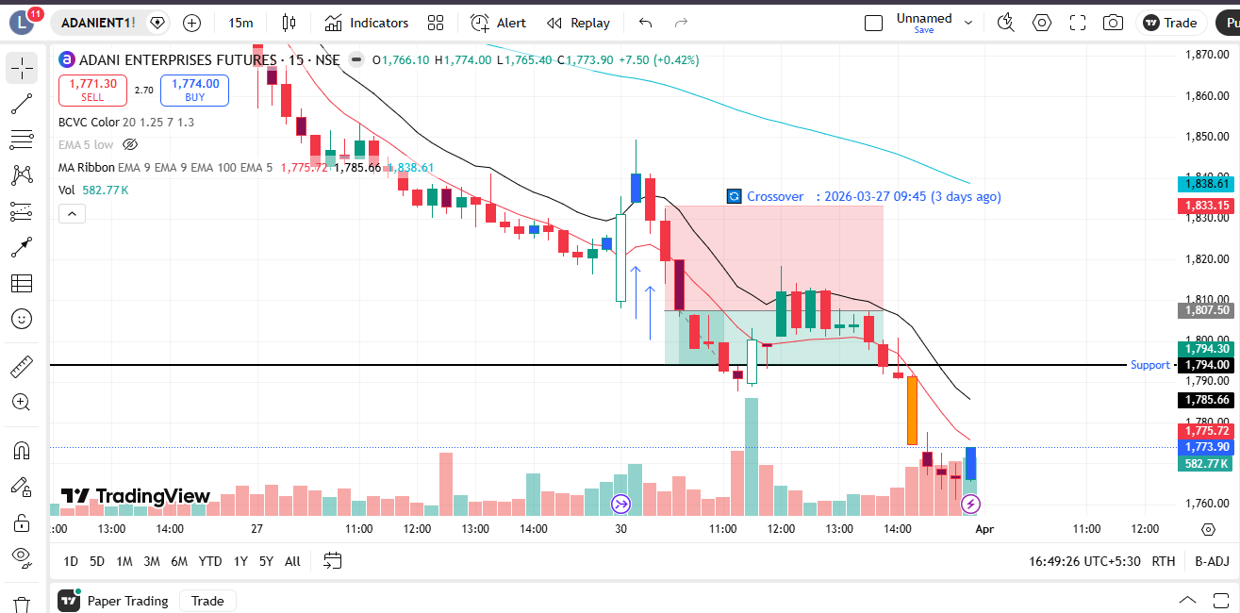
🔴 BEARISH SIGNAL --- BDL

Nifty Bias : 🔴 SHORT — Aligned ✅
Crossover : 2026-03-19 10:00 (11 days ago)
Pullback : 2026-03-30 09:30
High ₹1152.4 ≥ EMA9(High) ₹1151.36
Low ₹1135.8 (breakdown level)
Confirm : 2026-03-30 09:45 (+1 candle)
Close ₹1127 < Pullback Low ₹1135.8 (body breakdown)
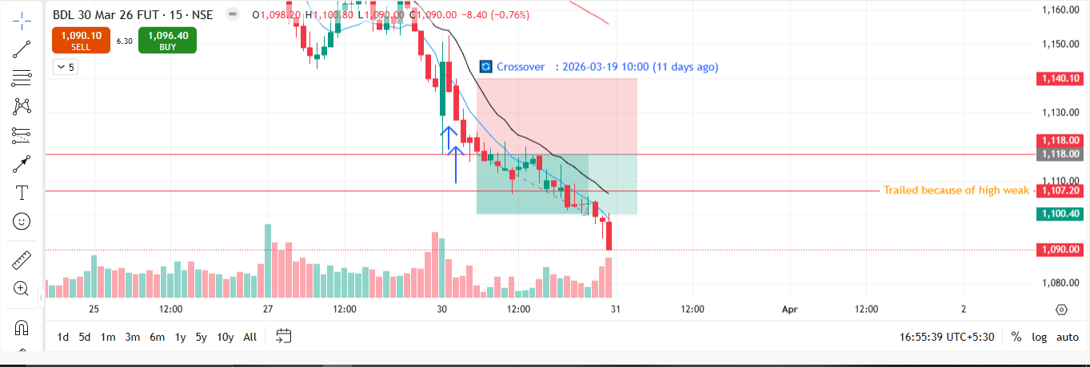
🔴 BEARISH SIGNAL --- MAZDOCK

Nifty Bias : 🔴 SHORT — Aligned ✅
Crossover : 2026-03-25 14:30 (5 days ago)
Pullback : 2026-03-30 09:30
High ₹2184.3 ≥ EMA9(High) ₹2183.5
Low ₹2153.5 (breakdown level)
Confirm : 2026-03-30 09:45 (+1 candle)
Close ₹2142.8 < Pullback Low ₹2153.5 (body breakdown)
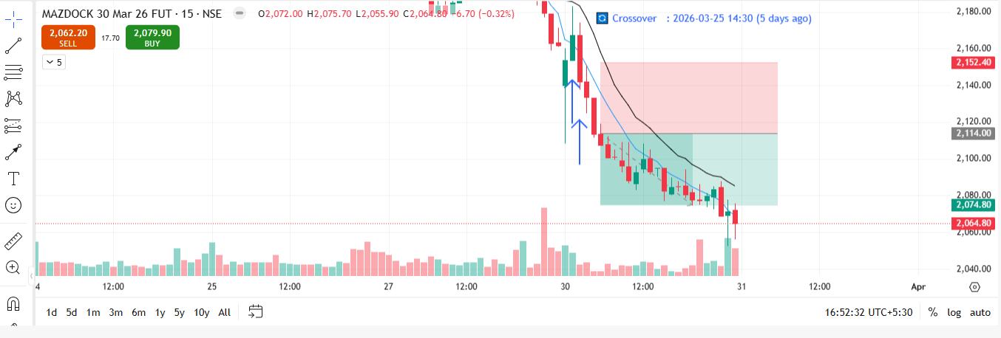
🔴 BEARISH SIGNAL --- BRITANNIA

Nifty Bias : 🔴 SHORT — Aligned ✅
Crossover : 2026-03-27 11:15 (3 days ago)
Pullback : 2026-03-30 09:45
High ₹5533 ≥ EMA9(High) ₹5530.78
Low ₹5495 (breakdown level)
Confirm : 2026-03-30 10:00 (+1 candle)
Close ₹5472.5 < Pullback Low ₹5495 (body breakdown)
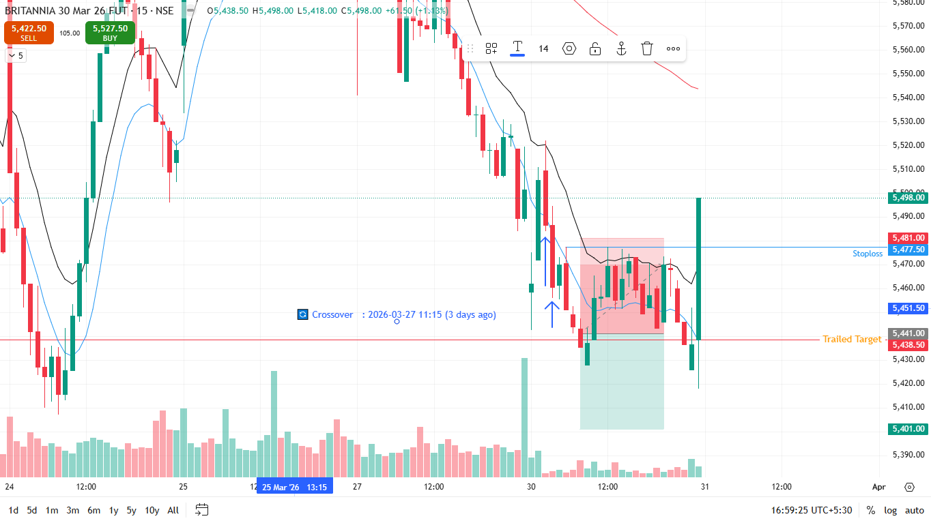
🔴 BEARISH SIGNAL --- HAL

Nifty Bias : 🔴 SHORT — Aligned ✅
Crossover : 2026-03-19 09:45 (11 days ago)
Pullback : 2026-03-30 09:45
High ₹3612 ≥ EMA9(High) ₹3604.09
Low ₹3585.4 (breakdown level)
Confirm : 2026-03-30 10:00 (+1 candle)
Close ₹3580.7 < Pullback Low ₹3585.4 (body breakdown)
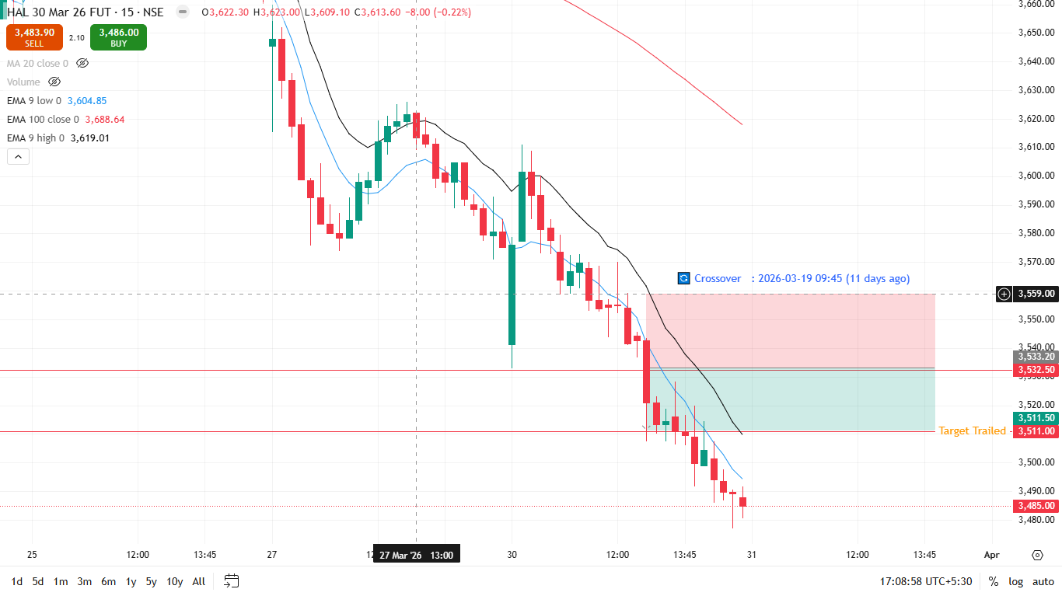
🔴 BEARISH SIGNAL --- IREDA

Nifty Bias : 🔴 SHORT — Aligned ✅
Crossover : 2026-03-27 14:00 (3 days ago)
Pullback : 2026-03-30 12:00
High ₹113.44 ≥ EMA9(High) ₹113.42
Low ₹112.71 (breakdown level)
Confirm : 2026-03-30 12:15 (+1 candle)
Close ₹112.27 < Pullback Low ₹112.71 (body breakdown)
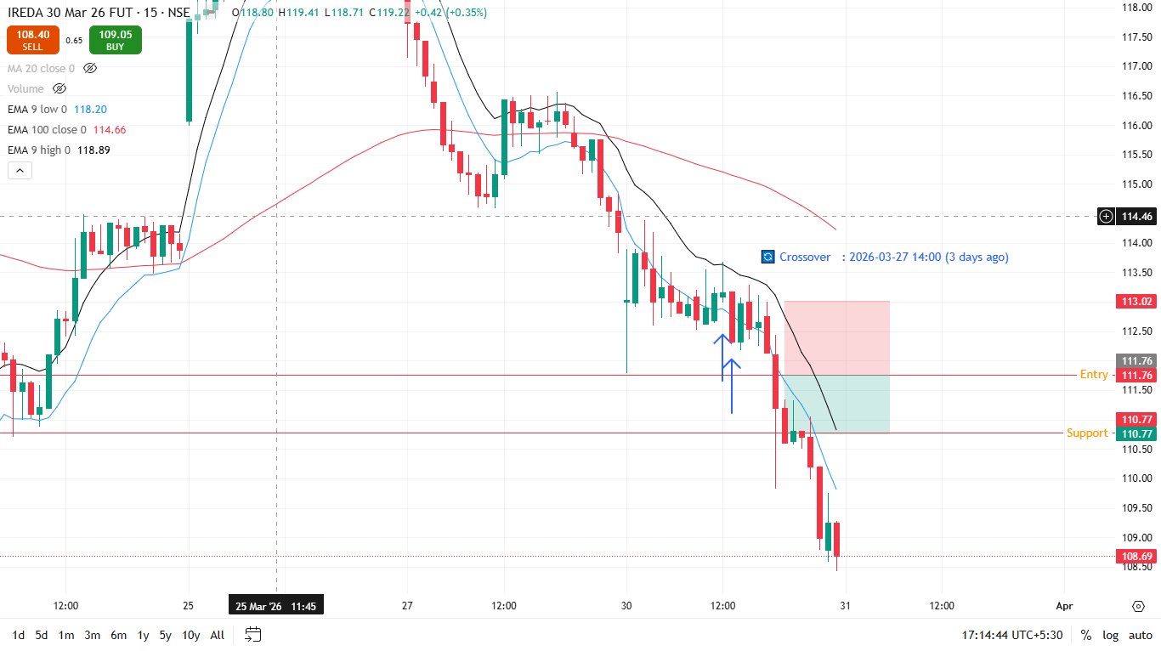
🔴 BEARISH SIGNAL --- TECHM

Nifty Bias : 🔴 SHORT — Aligned ✅
Crossover : 2026-03-27 13:30 (3 days ago)
Pullback : 2026-03-30 12:00
High ₹1390.7 ≥ EMA9(High) ₹1385.62
Low ₹1382.8 (breakdown level)
Confirm : 2026-03-30 12:15 (+1 candle)
Close ₹1382.7 < Pullback Low ₹1382.8 (body breakdown)
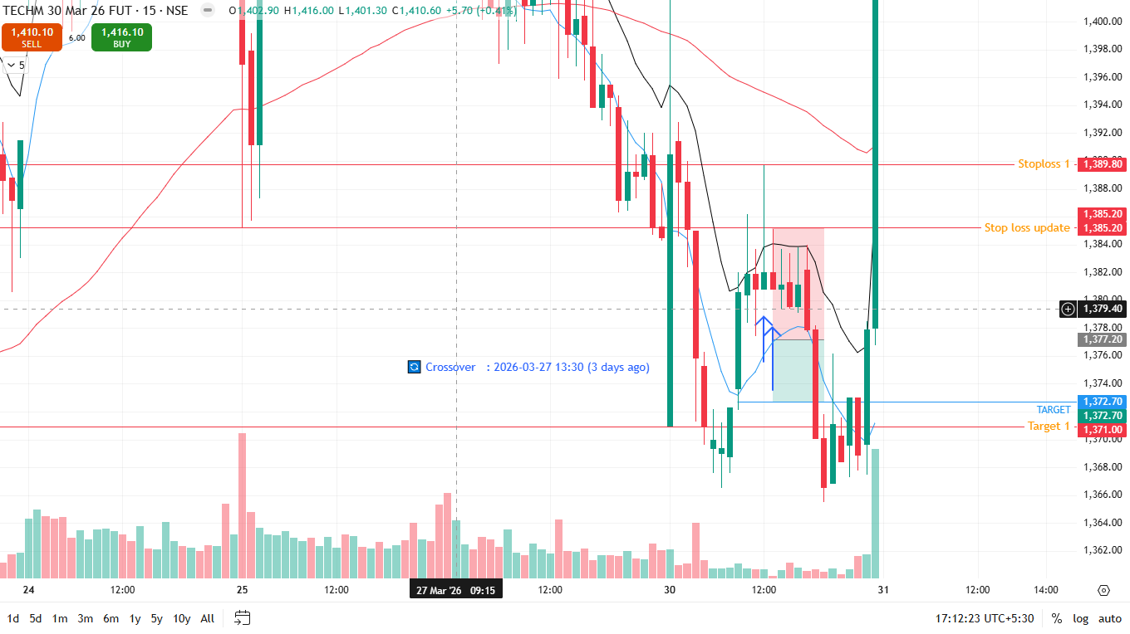
🔴 BEARISH SIGNAL --- ITC

Nifty Bias : 🔴 SHORT — Aligned ✅
Crossover : 2026-03-27 14:00 (3 days ago)
Pullback : 2026-03-30 12:15
High ₹292.05 ≥ EMA9(High) ₹291.93
Low ₹291.1 (breakdown level)
Confirm : 2026-03-30 12:30 (+1 candle)
Close ₹290.7 < Pullback Low ₹291.1 (body breakdown)
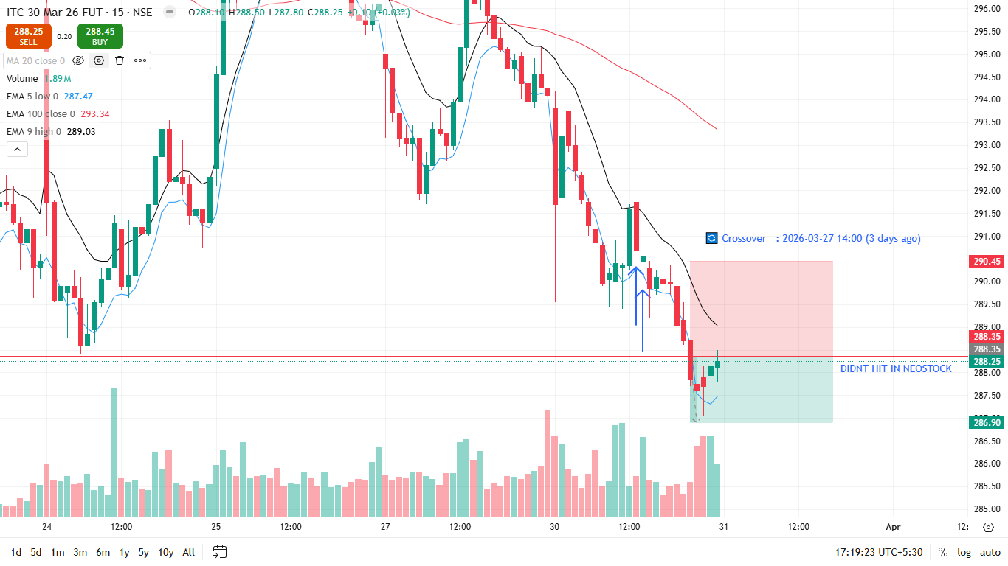
🔴 BEARISH SIGNAL --- COFORGE

Nifty Bias : 🔴 SHORT — Aligned ✅
Crossover : 2026-03-30 10:30 (3 hours ago)
Pullback : 2026-03-30 12:15
High ₹1132 ≥ EMA9(High) ₹1128.63
Low ₹1126.2 (breakdown level)
Confirm : 2026-03-30 12:45 (+2 candle)
Close ₹1125 < Pullback Low ₹1126.2 (body breakdown)
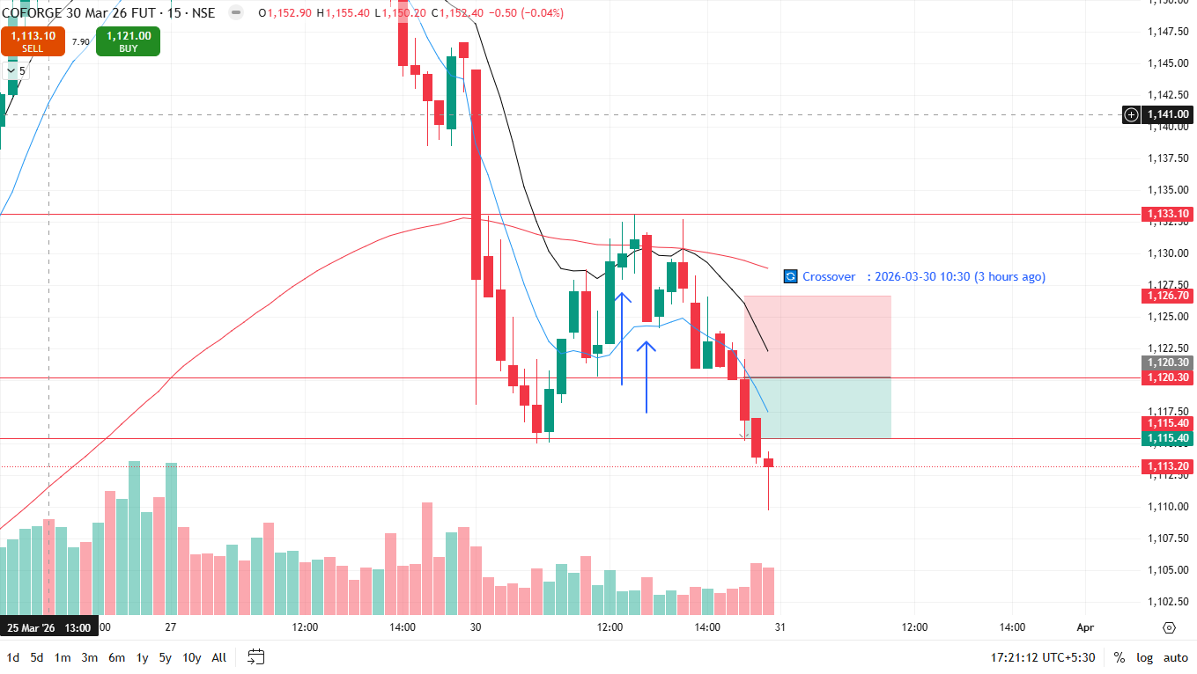
🔴 BEARISH SIGNAL --- TORNTPOWER

Nifty Bias : 🔴 SHORT — Aligned ✅
Crossover : 2026-03-25 15:00 (5 days ago)
Pullback : 2026-03-30 12:00
High ₹1331.6 ≥ EMA9(High) ₹1329.79
Low ₹1321.4 (breakdown level)
Confirm : 2026-03-30 12:45 (+3 candle)
Close ₹1318.5 < Pullback Low ₹1321.4 (body breakdown)
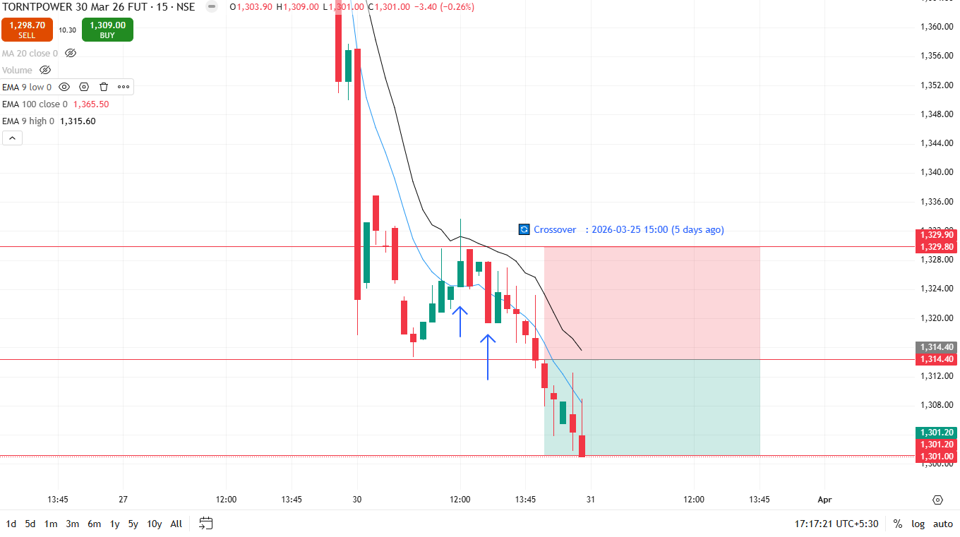

Trade Not Taken
🔴 BEARISH SIGNAL --- AUBANK

Nifty Bias : 🔴 SHORT — Aligned ✅
Crossover : 2026-03-27 12:00 (3 days ago)
Pullback : 2026-03-27 15:15
High ₹888 ≥ EMA9(High) ₹886.59
Low ₹877.25 (breakdown level)
Confirm : 2026-03-30 09:15 (+1 candle)
Close ₹859.1 < Pullback Low ₹877.25 (body breakdown)
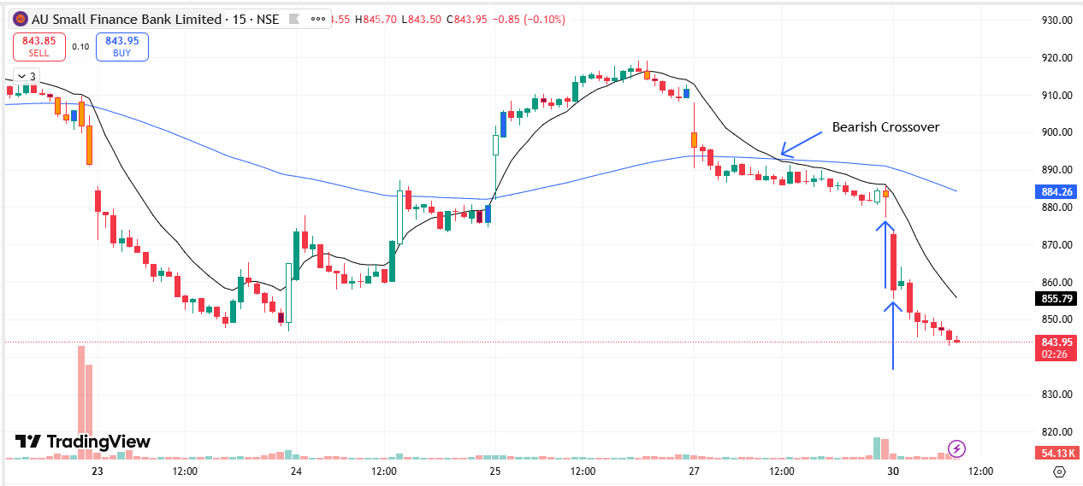
🔴 BEARISH SIGNAL --- ADANIPORTS

Nifty Bias : 🔴 SHORT — Aligned ✅
Crossover : 2026-03-27 10:45 (3 days ago)
Pullback : 2026-03-27 15:00
High ₹1343 ≥ EMA9(High) ₹1341.03
Low ₹1337.3 (breakdown level)
Confirm : 2026-03-30 09:15 (+2 candle)
Close ₹1329 < Pullback Low ₹1337.3 (body breakdown)
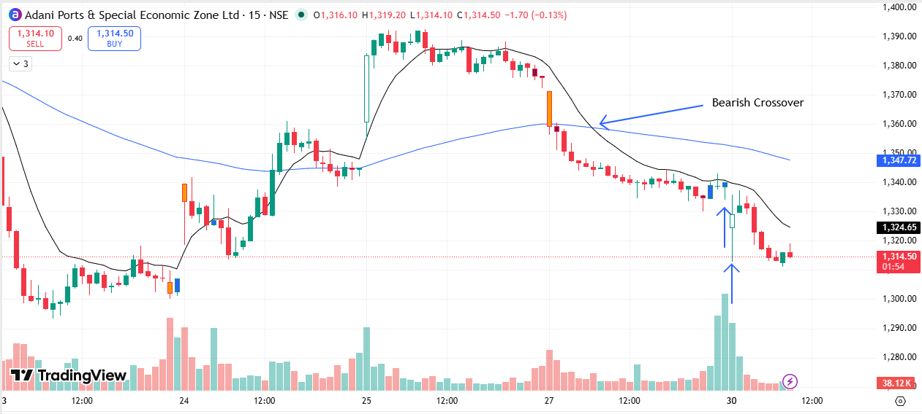
🔴 BEARISH SIGNAL --- ABCAPITAL

Nifty Bias : 🔴 SHORT — Aligned ✅
Crossover : 2026-03-27 10:45 (3 days ago)
Pullback : 2026-03-27 14:45
High ₹305.95 ≥ EMA9(High) ₹305.3
Low ₹303.65 (breakdown level)
Confirm : 2026-03-30 09:15 (+3 candle)
Close ₹296.8 < Pullback Low ₹303.65 (body breakdown)
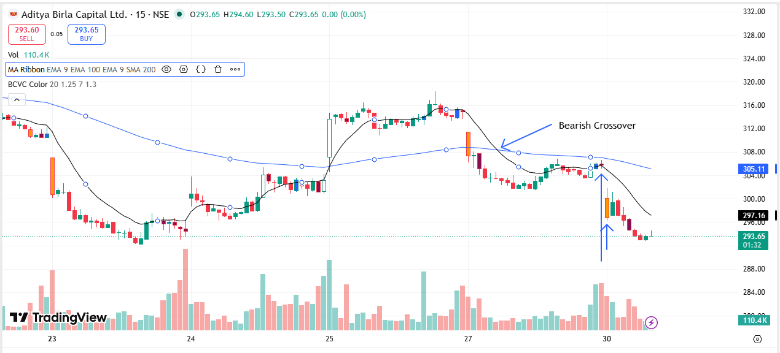
🔴 BEARISH SIGNAL --- BAJFINANCE

Nifty Bias : 🔴 SHORT — Aligned ✅
Crossover : 2026-03-27 14:00 (3 days ago)
Pullback : 2026-03-27 15:15
High ₹848.6 ≥ EMA9(High) ₹847.87
Low ₹841.25 (breakdown level)
Confirm : 2026-03-30 09:15 (+1 candle)
Close ₹828.35 < Pullback Low ₹841.25 (body breakdown)
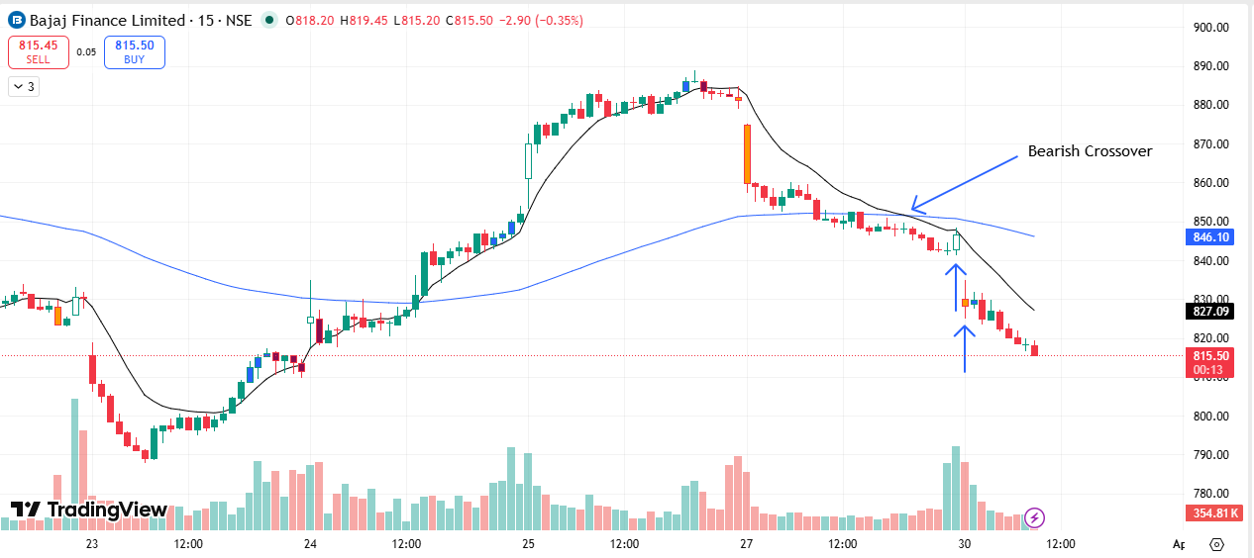
🔴 BEARISH SIGNAL --- BAJAJFINSV

Nifty Bias : 🔴 SHORT — Aligned ✅
Crossover : 2026-03-27 10:45 (3 days ago)
Pullback : 2026-03-27 15:00
High ₹1697.6 ≥ EMA9(High) ₹1693.93
Low ₹1692.1 (breakdown level)
Confirm : 2026-03-30 09:15 (+2 candle)
Close ₹1657.8 < Pullback Low ₹1692.1 (body breakdown)

🔴 BEARISH SIGNAL --- BANKBARODA

Nifty Bias : 🔴 SHORT — Aligned ✅
Crossover : 2026-03-27 09:15 (3 days ago)
Pullback : 2026-03-27 15:00
High ₹260.9 ≥ EMA9(High) ₹260.68
Low ₹259.2 (breakdown level)
Confirm : 2026-03-30 09:15 (+2 candle)
Close ₹254.35 < Pullback Low ₹259.2 (body breakdown)
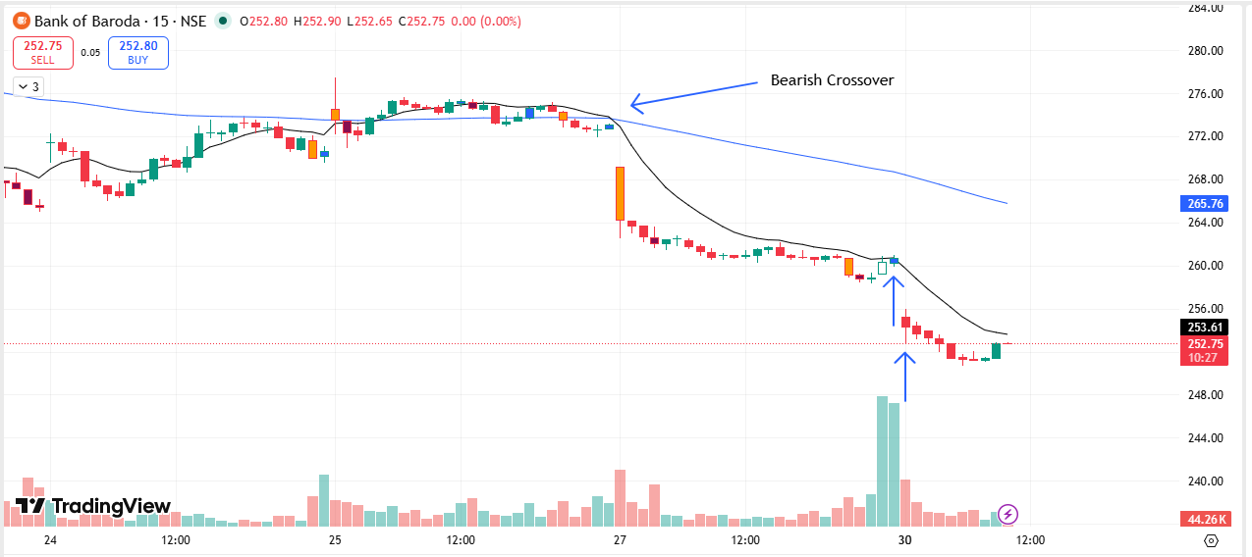
🔴 BEARISH SIGNAL --- BANKINDIA

Nifty Bias : 🔴 SHORT — Aligned ✅
Crossover : 2026-03-27 09:45 (3 days ago)
Pullback : 2026-03-27 15:00
High ₹145.48 ≥ EMA9(High) ₹144.95
Low ₹144.48 (breakdown level)
Confirm : 2026-03-30 09:15 (+2 candle)
Close ₹141.47 < Pullback Low ₹144.48 (body breakdown)
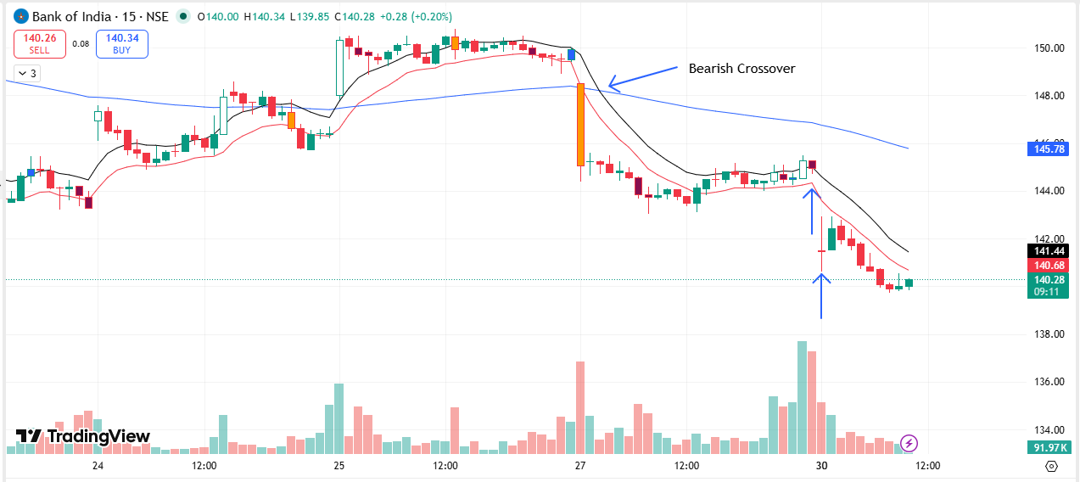
🔴 BEARISH SIGNAL --- COLPAL

Nifty Bias : 🔴 SHORT — Aligned ✅
Crossover : 2026-03-27 14:00 (3 days ago)
Pullback : 2026-03-27 15:15
High ₹1892.8 ≥ EMA9(High) ₹1892.72
Low ₹1876.1 (breakdown level)
Confirm : 2026-03-30 09:15 (+1 candle)
Close ₹1848.6 < Pullback Low ₹1876.1 (body breakdown)
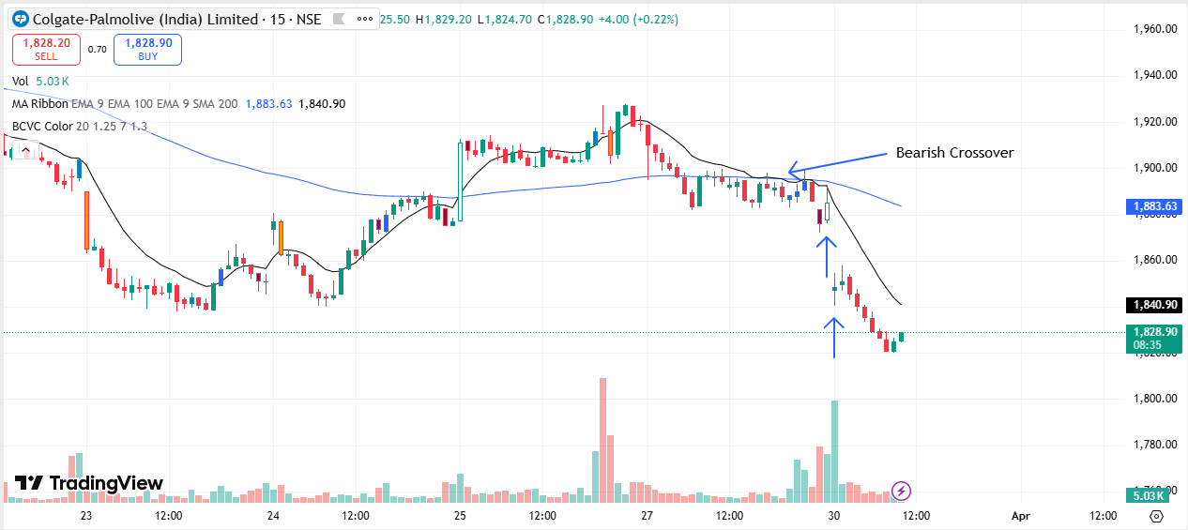
🔴 BEARISH SIGNAL --- CONCOR

Nifty Bias : 🔴 SHORT — Aligned ✅
Crossover : 2026-03-27 10:30 (3 days ago)
Pullback : 2026-03-27 15:15
High ₹440.9 ≥ EMA9(High) ₹438.26
Low ₹435.3 (breakdown level)
Confirm : 2026-03-30 09:15 (+1 candle)
Close ₹432.3 < Pullback Low ₹435.3 (body breakdown)
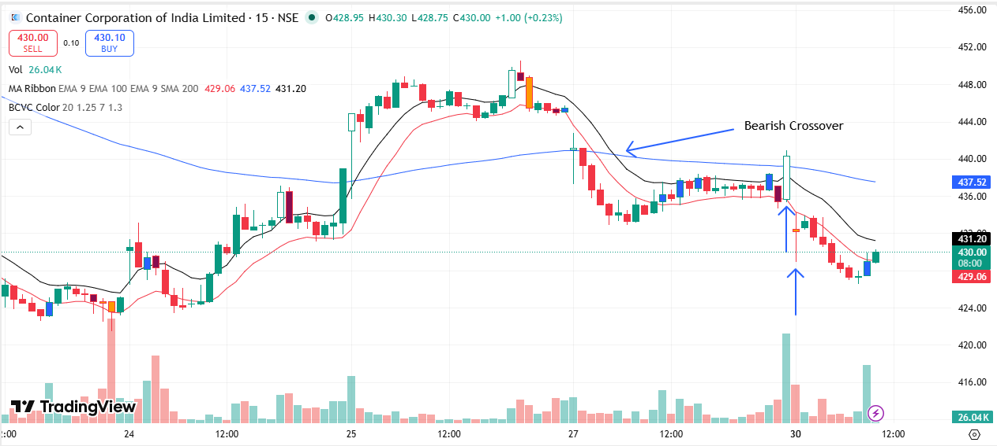
🔴 BEARISH SIGNAL --- DIVISLAB

Nifty Bias : 🔴 SHORT — Aligned ✅
Crossover : 2026-03-25 15:15 (5 days ago)
Pullback : 2026-03-27 15:15
High ₹6060 ≥ EMA9(High) ₹6033.65
Low ₹5983 (breakdown level)
Confirm : 2026-03-30 09:15 (+1 candle)
Close ₹5909.5 < Pullback Low ₹5983 (body breakdown)
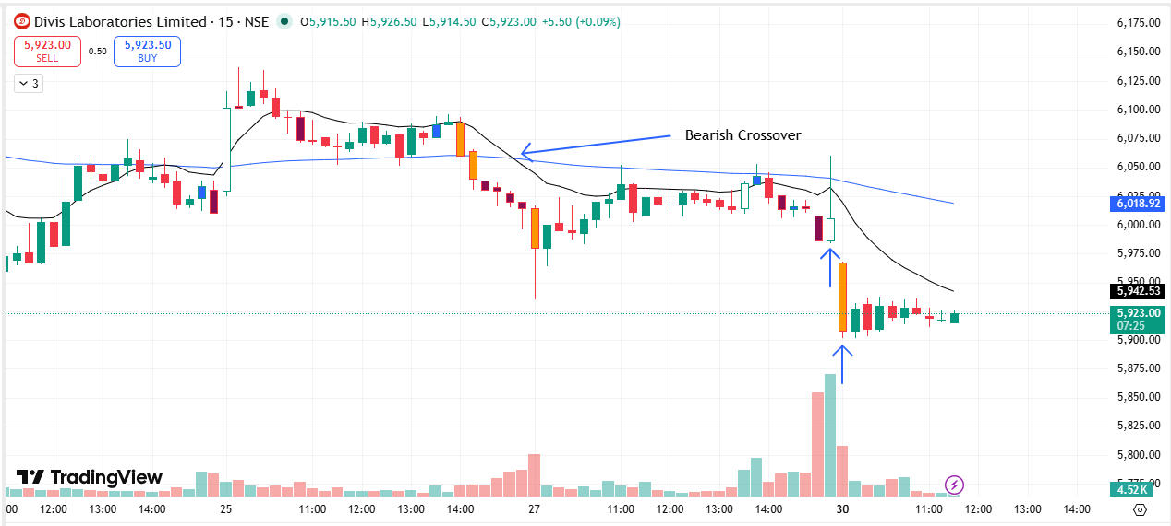
🔴 BEARISH SIGNAL --- NYKAA

Nifty Bias : 🔴 SHORT — Aligned ✅
Crossover : 2026-03-27 11:45 (3 days ago)
Pullback : 2026-03-27 14:45
High ₹239.9 ≥ EMA9(High) ₹239.85
Low ₹238.15 (breakdown level)
Confirm : 2026-03-30 09:15 (+3 candle)
Close ₹234.45 < Pullback Low ₹238.15 (body breakdown)
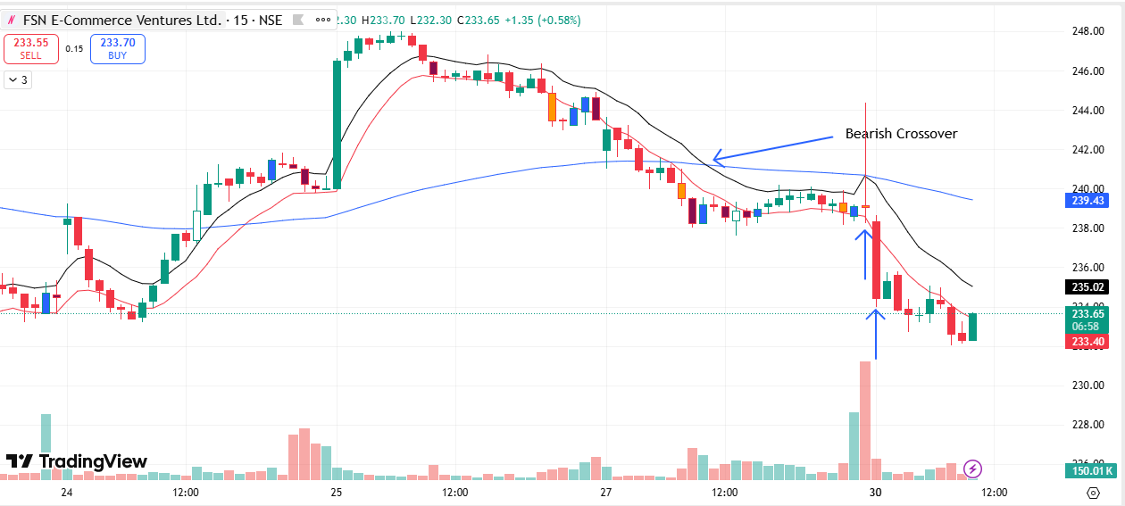
🔴 BEARISH SIGNAL --- GMRAIRPORT

Nifty Bias : 🔴 SHORT — Aligned ✅
Crossover : 2026-03-27 10:30 (3 days ago)
Pullback : 2026-03-27 14:45
High ₹89.15 ≥ EMA9(High) ₹88.93
Low ₹88.95 (breakdown level)
Confirm : 2026-03-30 09:15 (+3 candle)
Close ₹86.9 < Pullback Low ₹88.95 (body breakdown)
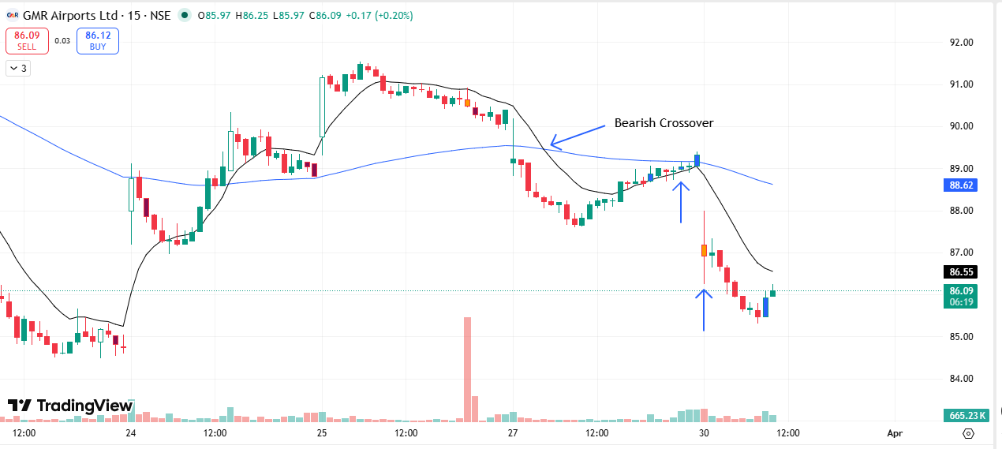
🔴 BEARISH SIGNAL --- GODREJPROP

Nifty Bias : 🔴 SHORT — Aligned ✅
Crossover : 2026-03-27 09:45 (3 days ago)
Pullback : 2026-03-27 15:15
High ₹1516 ≥ EMA9(High) ₹1511.36
Low ₹1498.8 (breakdown level)
Confirm : 2026-03-30 09:15 (+1 candle)
Close ₹1487.7 < Pullback Low ₹1498.8 (body breakdown)
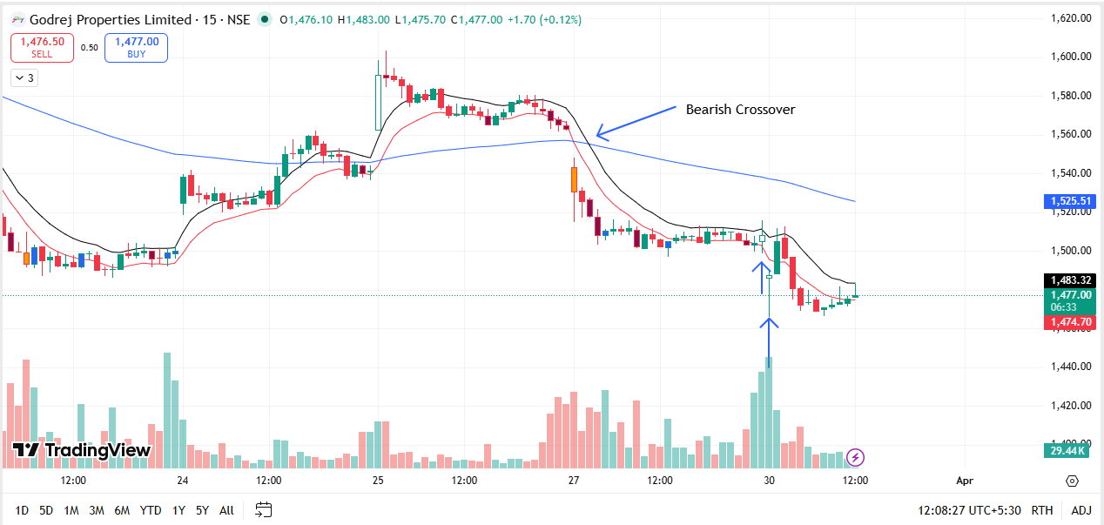
🔴 BEARISH SIGNAL --- HDFCAMC

Nifty Bias : 🔴 SHORT — Aligned ✅
Crossover : 2026-03-27 10:00 (3 days ago)
Pullback : 2026-03-27 15:15
High ₹2330 ≥ EMA9(High) ₹2323.82
Low ₹2315.5 (breakdown level)
Confirm : 2026-03-30 09:15 (+1 candle)
Close ₹2280.9 < Pullback Low ₹2315.5 (body breakdown)
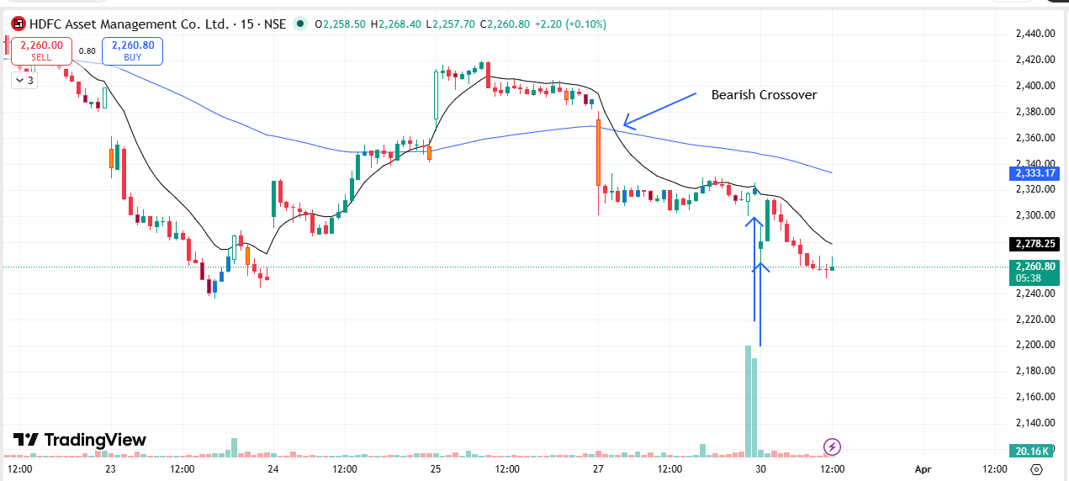
🔴 BEARISH SIGNAL --- HAVELLS

Nifty Bias : 🔴 SHORT — Aligned ✅
Crossover : 2026-03-27 10:15 (3 days ago)
Pullback : 2026-03-27 15:00
High ₹1236.7 ≥ EMA9(High) ₹1235.57
Low ₹1226.9 (breakdown level)
Confirm : 2026-03-30 09:15 (+2 candle)
Close ₹1211 < Pullback Low ₹1226.9 (body breakdown)
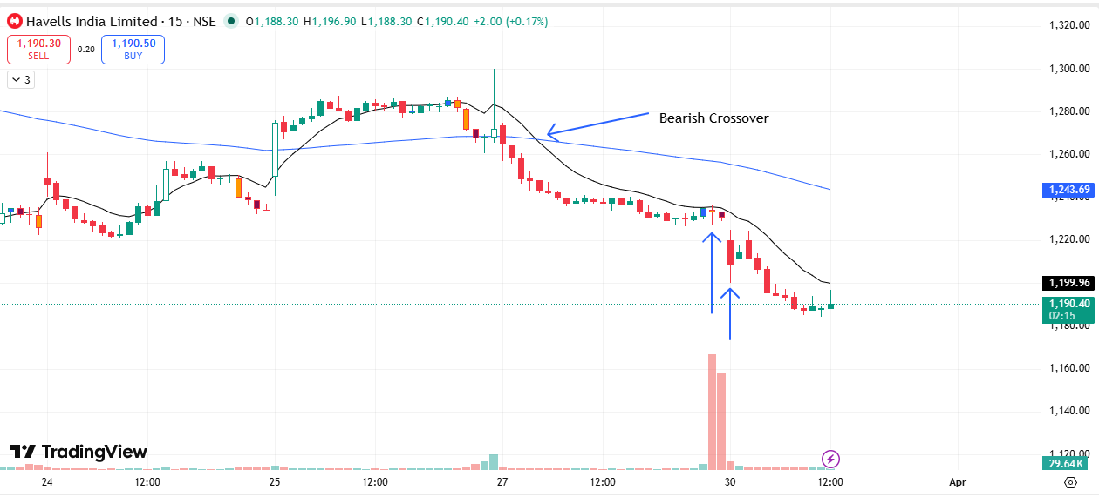
🔴 BEARISH SIGNAL --- ICICIPRULI

Nifty Bias : 🔴 SHORT — Aligned ✅
Crossover : 2026-03-25 13:15 (5 days ago)
Pullback : 2026-03-27 15:00
High ₹533.25 ≥ EMA9(High) ₹532.56
Low ₹529.65 (breakdown level)
Confirm : 2026-03-30 09:15 (+2 candle)
Close ₹518.15 < Pullback Low ₹529.65 (body breakdown)
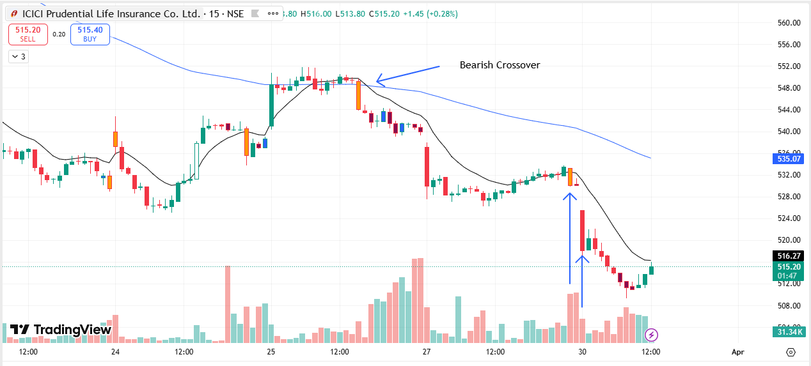
🔴 BEARISH SIGNAL --- IDFCFIRSTB

Nifty Bias : 🔴 SHORT — Aligned ✅
Crossover : 2026-03-27 10:45 (3 days ago)
Pullback : 2026-03-27 15:00
High ₹61.96 ≥ EMA9(High) ₹61.85
Low ₹61.62 (breakdown level)
Confirm : 2026-03-30 09:15 (+2 candle)
Close ₹59.99 < Pullback Low ₹61.62 (body breakdown)
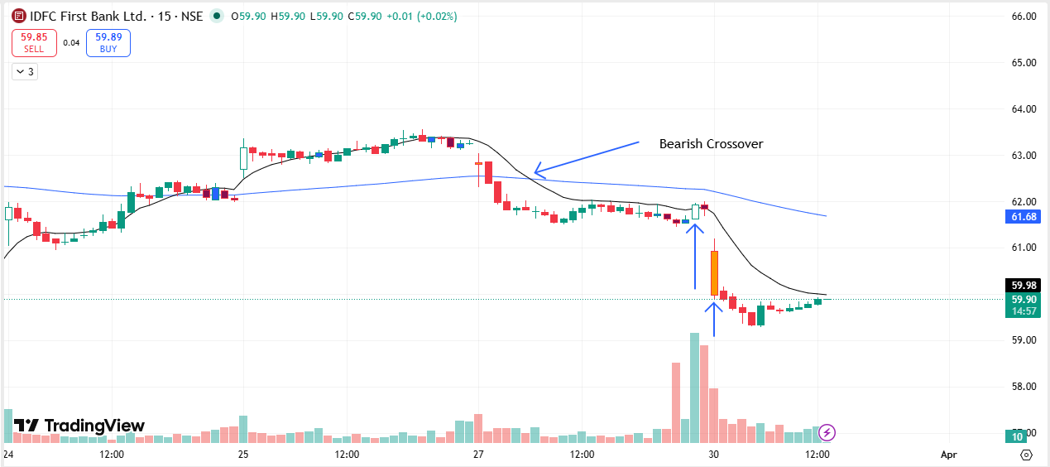
🔴 BEARISH SIGNAL --- IIFL

Nifty Bias : 🔴 SHORT — Aligned ✅
Crossover : 2026-03-27 09:45 (3 days ago)
Pullback : 2026-03-27 15:00
High ₹450.6 ≥ EMA9(High) ₹449.99
Low ₹445.95 (breakdown level)
Confirm : 2026-03-30 09:15 (+2 candle)
Close ₹439.5 < Pullback Low ₹445.95 (body breakdown)
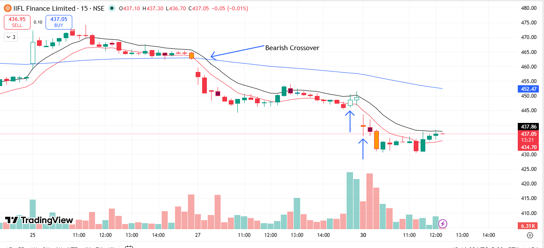
🔴 BEARISH SIGNAL --- IGL

Nifty Bias : 🔴 SHORT — Aligned ✅
Crossover : 2026-03-25 13:45 (5 days ago)
Pullback : 2026-03-27 15:00
High ₹149.6 ≥ EMA9(High) ₹148.82
Low ₹146.82 (breakdown level)
Confirm : 2026-03-30 09:15 (+2 candle)
Close ₹145.93 < Pullback Low ₹146.82 (body breakdown)
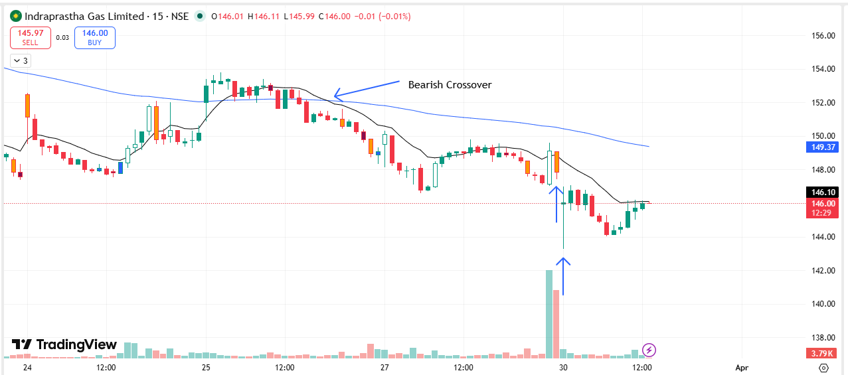
🔴 BEARISH SIGNAL --- INDUSINDBK

Nifty Bias : 🔴 SHORT — Aligned ✅
Crossover : 2026-03-27 10:30 (3 days ago)
Pullback : 2026-03-27 15:15
High ₹795.25 ≥ EMA9(High) ₹795.02
Low ₹789 (breakdown level)
Confirm : 2026-03-30 09:15 (+1 candle)
Close ₹767.05 < Pullback Low ₹789 (body breakdown)
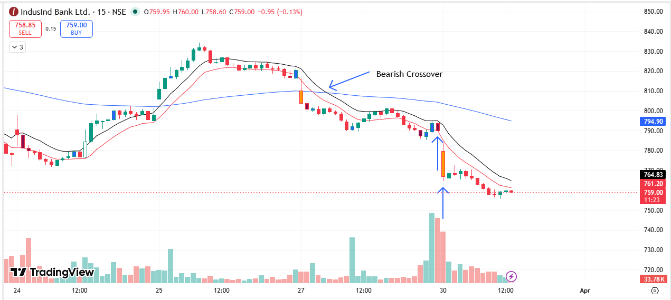
🔴 BEARISH SIGNAL --- JIOFIN

Nifty Bias : 🔴 SHORT — Aligned ✅
Crossover : 2026-03-27 10:30 (3 days ago)
Pullback : 2026-03-27 15:15
High ₹232.95 ≥ EMA9(High) ₹232.91
Low ₹231.55 (breakdown level)
Confirm : 2026-03-30 09:15 (+1 candle)
Close ₹229.75 < Pullback Low ₹231.55 (body breakdown)
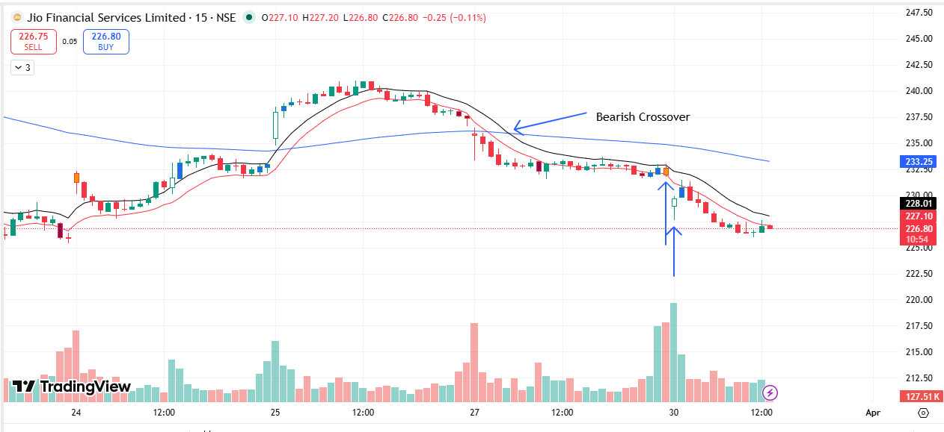
🔴 BEARISH SIGNAL --- JUBLFOOD

Nifty Bias : 🔴 SHORT — Aligned ✅
Crossover : 2026-03-27 14:00 (3 days ago)
Pullback : 2026-03-27 15:00
High ₹455.8 ≥ EMA9(High) ₹455.31
Low ₹448.5 (breakdown level)
Confirm : 2026-03-30 09:15 (+2 candle)
Close ₹438.7 < Pullback Low ₹448.5 (body breakdown)
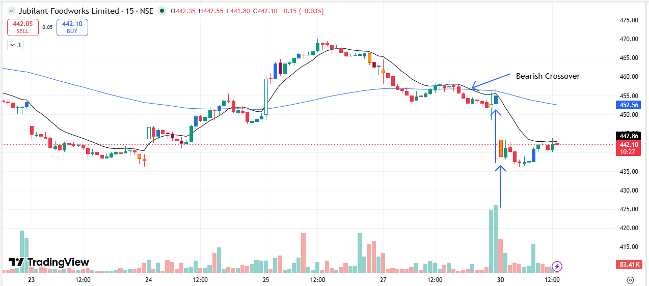
🔴 BEARISH SIGNAL --- KFINTECH

Nifty Bias : 🔴 SHORT — Aligned ✅
Crossover : 2026-03-27 13:45 (3 days ago)
Pullback : 2026-03-27 14:45
High ₹915 ≥ EMA9(High) ₹914.97
Low ₹909.4 (breakdown level)
Confirm : 2026-03-30 09:15 (+3 candle)
Close ₹895.1 < Pullback Low ₹909.4 (body breakdown)
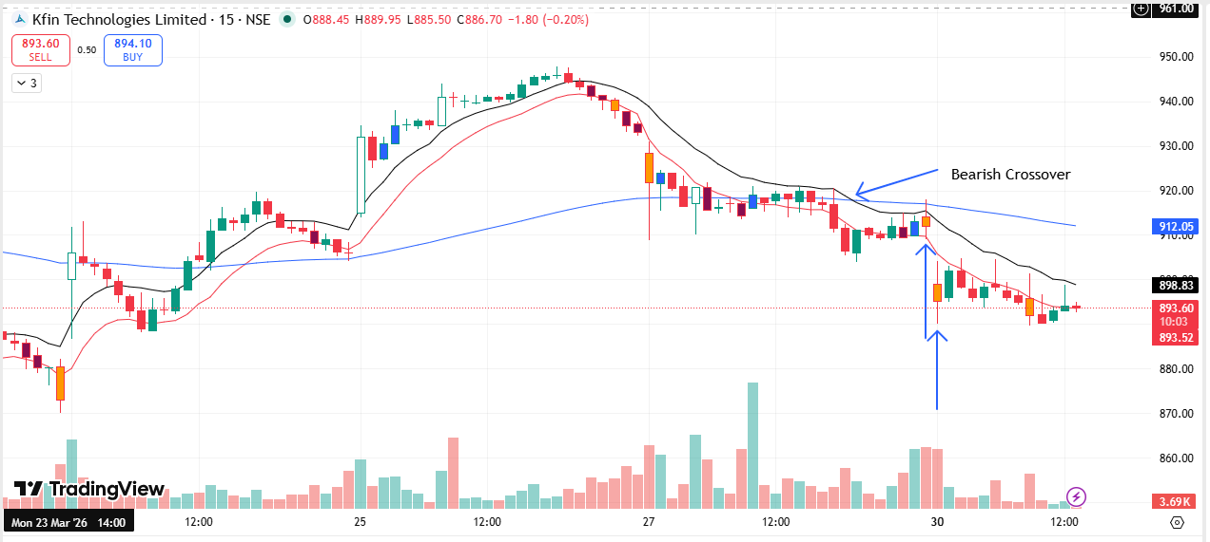
🔴 BEARISH SIGNAL --- KOTAKBANK

Nifty Bias : 🔴 SHORT — Aligned ✅
Crossover : 2026-03-27 10:15 (3 days ago)
Pullback : 2026-03-27 15:00
High ₹367.05 ≥ EMA9(High) ₹365.4
Low ₹364.3 (breakdown level)
Confirm : 2026-03-30 09:15 (+2 candle)
Close ₹354.6 < Pullback Low ₹364.3 (body breakdown)
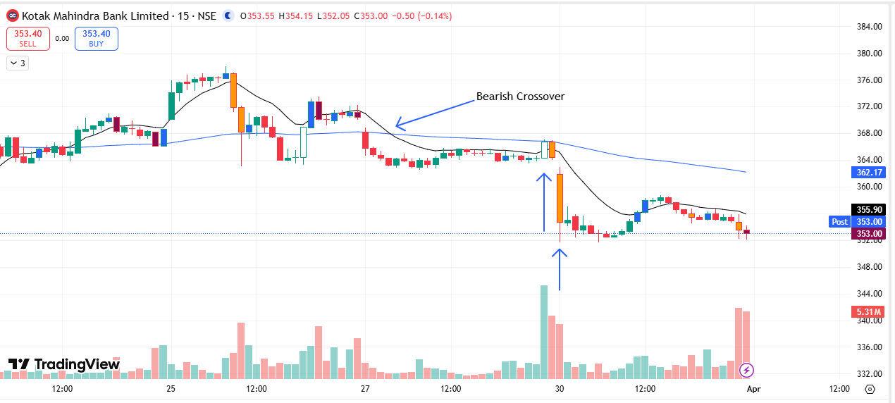
🔴 BEARISH SIGNAL --- LTF

Nifty Bias : 🔴 SHORT — Aligned ✅
Crossover : 2026-03-27 10:15 (3 days ago)
Pullback : 2026-03-27 14:45
High ₹253 ≥ EMA9(High) ₹252.49
Low ₹251.25 (breakdown level)
Confirm : 2026-03-30 09:15 (+3 candle)
Close ₹244.85 < Pullback Low ₹251.25 (body breakdown)
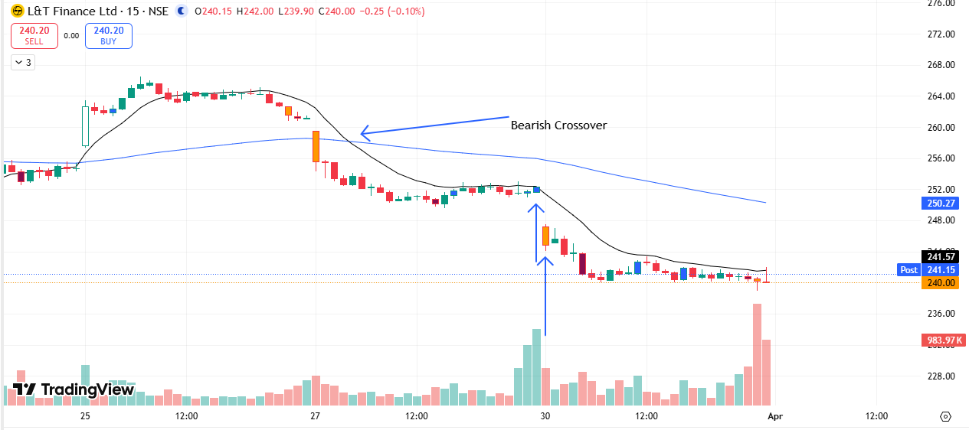
🔴 BEARISH SIGNAL --- MANAPPURAM

Nifty Bias : 🔴 SHORT — Aligned ✅
Crossover : 2026-03-27 10:45 (3 days ago)
Pullback : 2026-03-27 15:15
High ₹255.5 ≥ EMA9(High) ₹255.11
Low ₹253.15 (breakdown level)
Confirm : 2026-03-30 09:15 (+1 candle)
Close ₹251.3 < Pullback Low ₹253.15 (body breakdown)
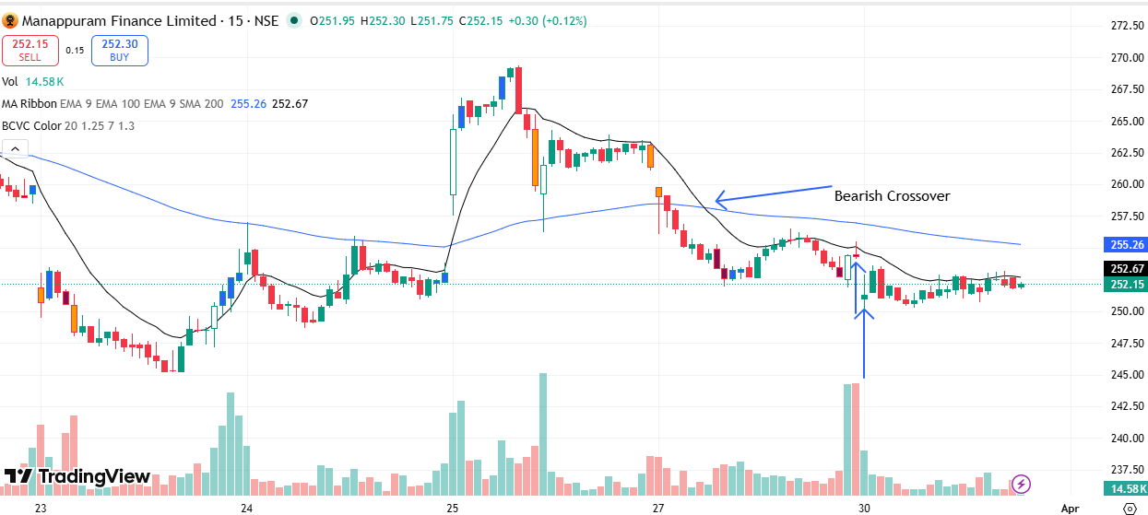
🔴 BEARISH SIGNAL --- MARUTI

Nifty Bias : 🔴 SHORT — Aligned ✅
Crossover : 2026-03-27 10:15 (3 days ago)
Pullback : 2026-03-27 15:15
High ₹12456 ≥ EMA9(High) ₹12419.16
Low ₹12349 (breakdown level)
Confirm : 2026-03-30 09:15 (+1 candle)
Close ₹12285 < Pullback Low ₹12349 (body breakdown)
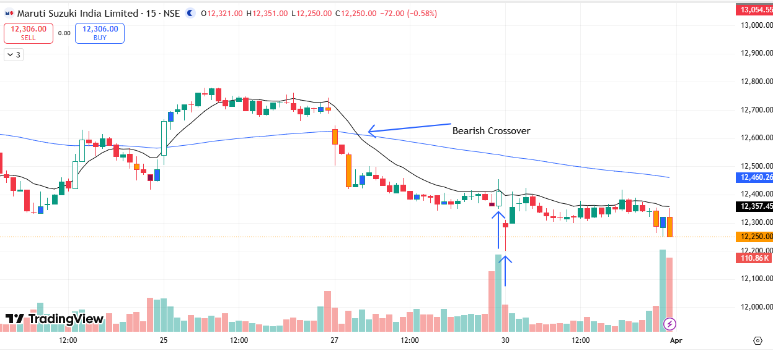
🔴 BEARISH SIGNAL --- MFSL

Nifty Bias : 🔴 SHORT — Aligned ✅
Crossover : 2026-03-25 15:00 (5 days ago)
Pullback : 2026-03-27 15:15
High ₹1568.2 ≥ EMA9(High) ₹1563.54
Low ₹1550 (breakdown level)
Confirm : 2026-03-30 09:15 (+1 candle)
Close ₹1528.5 < Pullback Low ₹1550 (body breakdown)
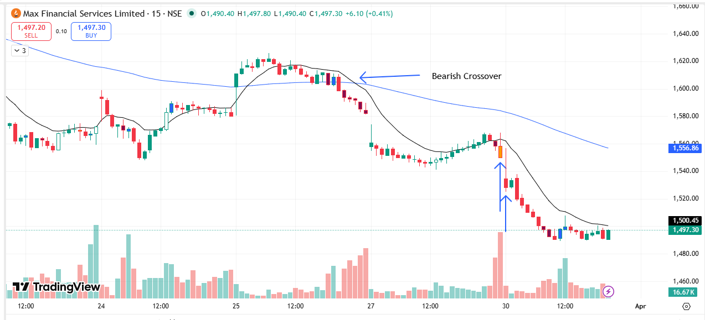
🟢 BULLISH SIGNAL --- ONGC

Nifty Bias : 🔴 SHORT — Counter Trend ⚠️
Crossover : 2026-03-25 10:30 (5 days ago)
Pullback : 2026-03-27 15:15
Low ₹280.85 ≤ EMA9(Low) ₹281.81
High ₹282.5 (breakout level)
Confirm : 2026-03-30 09:15 (+1 candle)
Close ₹286.4 > Pullback High ₹282.5 (body breakout)
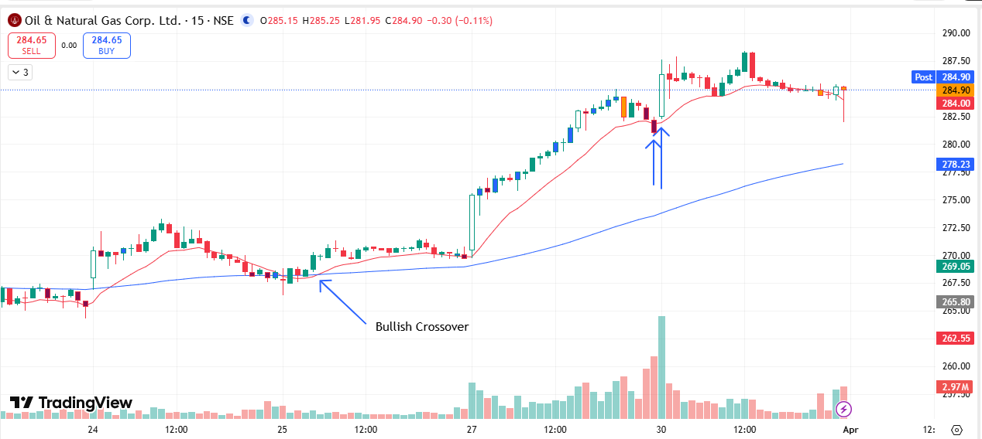
🟢 BULLISH SIGNAL --- OIL

Nifty Bias : 🔴 SHORT — Counter Trend ⚠️
Crossover : 2026-03-27 13:45 (3 days ago)
Pullback : 2026-03-27 15:00
Low ₹476.75 ≤ EMA9(Low) ₹478.03
High ₹480.2 (breakout level)
Confirm : 2026-03-30 09:15 (+2 candle)
Close ₹488.4 > Pullback High ₹480.2 (body breakout)
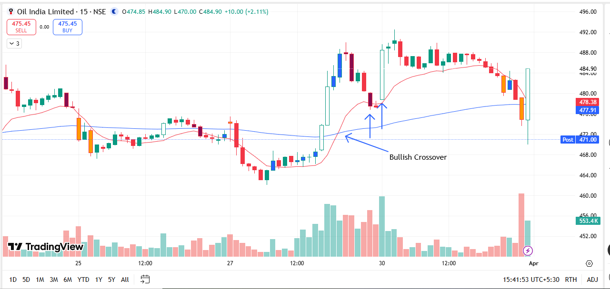
🔴 BEARISH SIGNAL --- POLYCAB

Nifty Bias : 🔴 SHORT — Aligned ✅
Crossover : 2026-03-27 10:15 (3 days ago)
Pullback : 2026-03-27 15:00
High ₹7076.5 ≥ EMA9(High) ₹7070.17
Low ₹7039.5 (breakdown level)
Confirm : 2026-03-30 09:15 (+2 candle)
Close ₹7006.5 < Pullback Low ₹7039.5 (body breakdown)
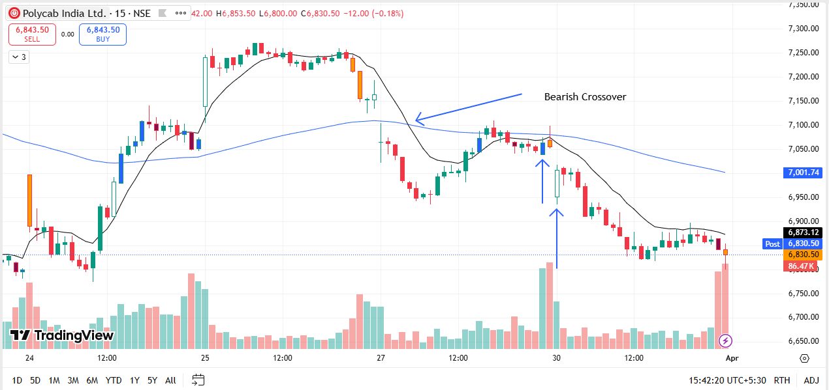
🔴 BEARISH SIGNAL --- SONACOMS

Nifty Bias : 🔴 SHORT — Aligned ✅
Crossover : 2026-03-27 10:45 (3 days ago)
Pullback : 2026-03-27 15:15
High ₹492 ≥ EMA9(High) ₹491.35
Low ₹485.85 (breakdown level)
Confirm : 2026-03-30 09:15 (+1 candle)
Close ₹475.95 < Pullback Low ₹485.85 (body breakdown)
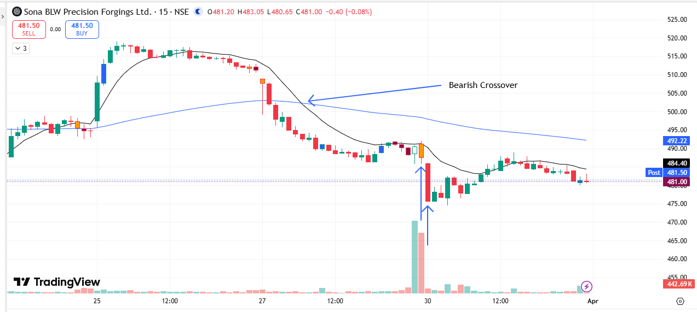
🔴 BEARISH SIGNAL --- TRENT

Nifty Bias : 🔴 SHORT — Aligned ✅
Crossover : 2026-03-27 11:45 (3 days ago)
Pullback : 2026-03-27 15:15
High ₹3421 ≥ EMA9(High) ₹3407.85
Low ₹3396 (breakdown level)
Confirm : 2026-03-30 09:15 (+1 candle)
Close ₹3327.4 < Pullback Low ₹3396 (body breakdown)
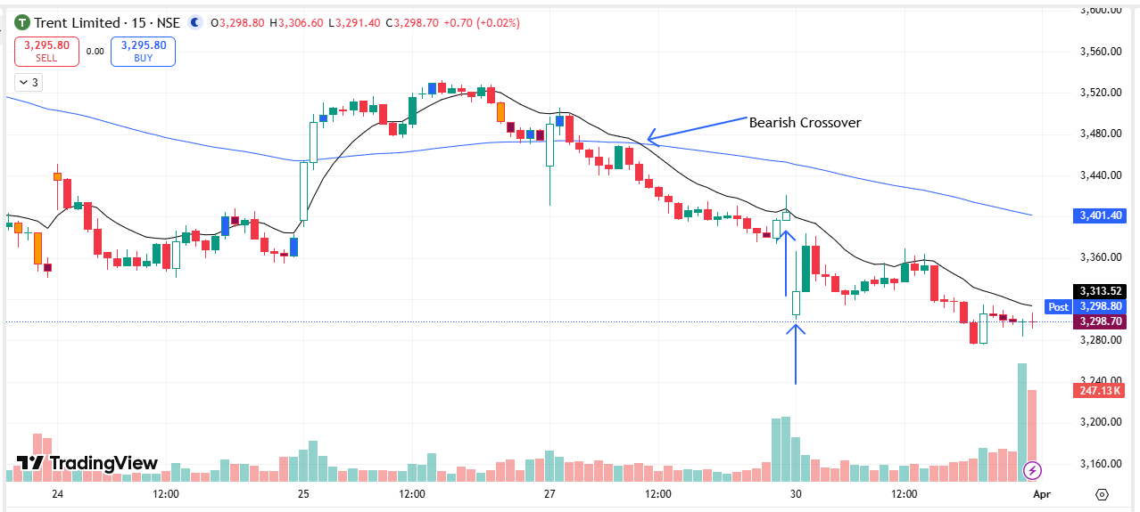
🔴 BEARISH SIGNAL --- UNOMINDA

Nifty Bias : 🔴 SHORT — Aligned ✅
Crossover : 2026-03-27 11:30 (3 days ago)
Pullback : 2026-03-27 15:15
High ₹1054 ≥ EMA9(High) ₹1051.97
Low ₹1047.5 (breakdown level)
Confirm : 2026-03-30 09:15 (+1 candle)
Close ₹1046.4 < Pullback Low ₹1047.5 (body breakdown)
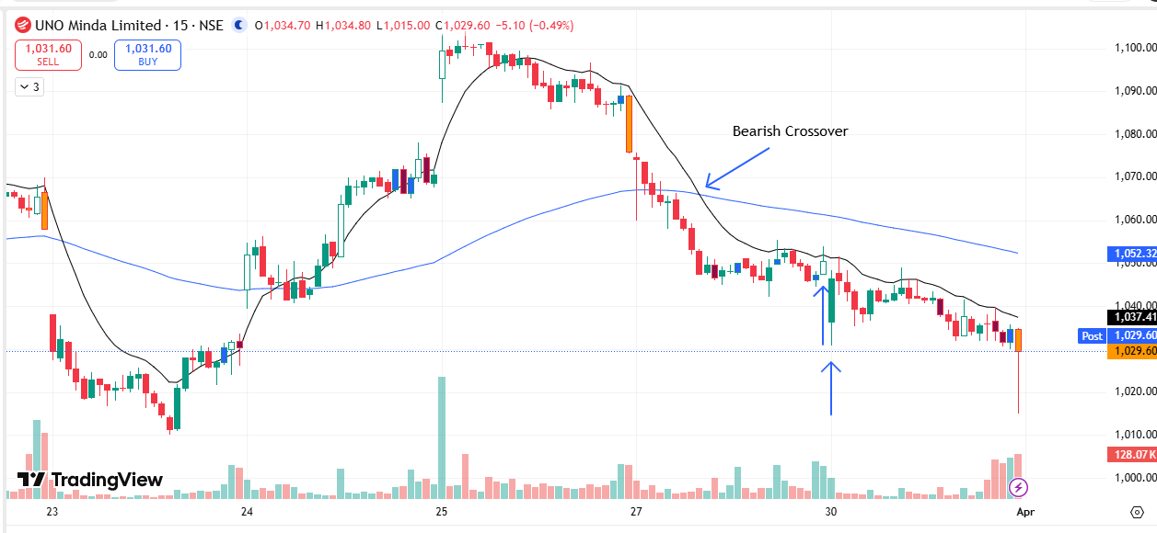
🔴 BEARISH SIGNAL --- UNIONBANK

Nifty Bias : 🔴 SHORT — Aligned ✅
Crossover : 2026-03-27 11:00 (3 days ago)
Pullback : 2026-03-27 15:00
High ₹175.85 ≥ EMA9(High) ₹174.74
Low ₹172.67 (breakdown level)
Confirm : 2026-03-30 09:15 (+2 candle)
Close ₹171.48 < Pullback Low ₹172.67 (body breakdown)
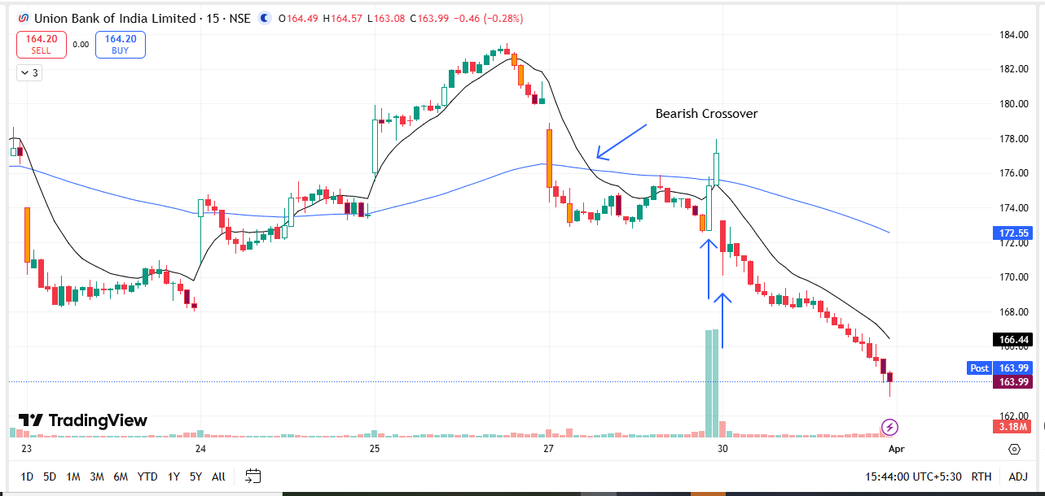
🔴 BEARISH SIGNAL --- YESBANK

Nifty Bias : 🔴 SHORT — Aligned ✅
Crossover : 2026-03-27 10:30 (3 days ago)
Pullback : 2026-03-27 15:00
High ₹18.14 ≥ EMA9(High) ₹18.07
Low ₹18 (breakdown level)
Confirm : 2026-03-30 09:15 (+2 candle)
Close ₹17.69 < Pullback Low ₹18 (body breakdown)
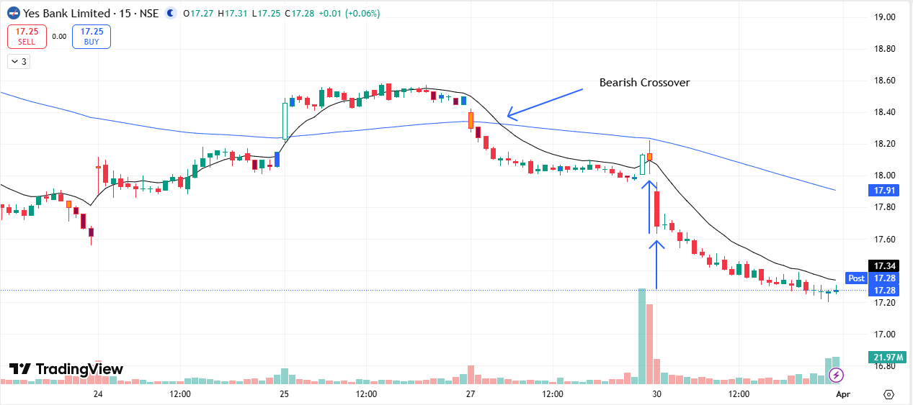
🟢 BULLISH SIGNAL --- KALYANKJIL

Nifty Bias : 🔴 SHORT — Counter Trend ⚠️
Crossover : 2026-03-25 09:45 (5 days ago)
Pullback : 2026-03-30 09:15
Low ₹379.45 ≤ EMA9(Low) ₹387.11
High ₹385.3 (breakout level)
Confirm : 2026-03-30 09:30 (+1 candle)
Close ₹386.85 > Pullback High ₹385.3 (body breakout)
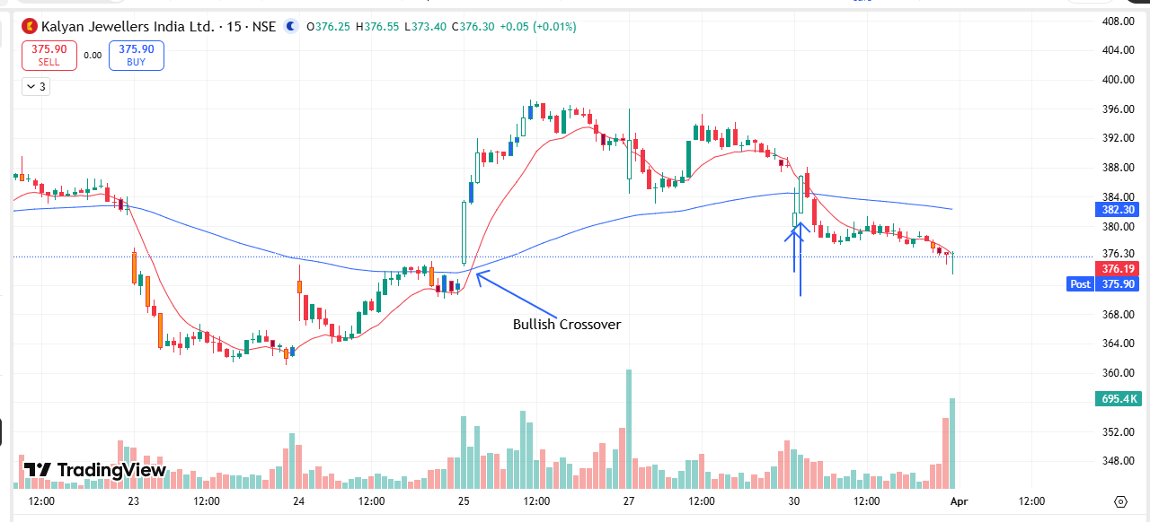
🟢 BULLISH SIGNAL --- NATIONALUM

Nifty Bias : 🔴 SHORT — Counter Trend ⚠️
Crossover : 2026-03-25 11:45 (5 days ago)
Pullback : 2026-03-27 15:00
Low ₹369.35 ≤ EMA9(Low) ₹369.72
High ₹371.7 (breakout level)
Confirm : 2026-03-30 09:15 (+2 candle)
Close ₹391.05 > Pullback High ₹371.7 (body breakout)
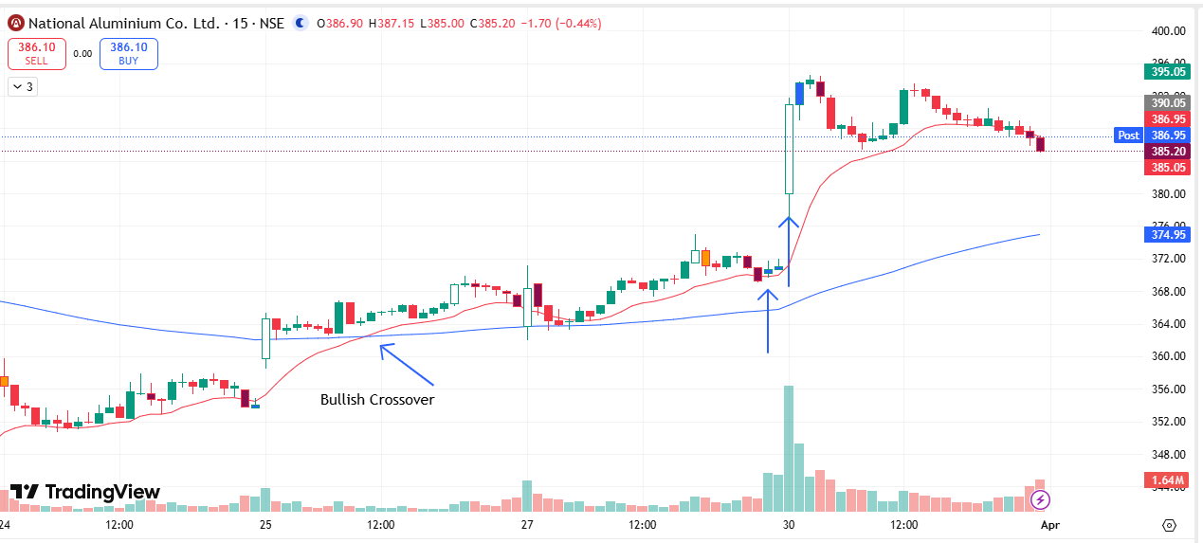
🔴 BEARISH SIGNAL --- ADANIGREEN

Nifty Bias : 🔴 SHORT — Aligned ✅
Crossover : 2026-03-27 10:30 (3 days ago)
Pullback : 2026-03-27 15:15
High ₹834 ≥ EMA9(High) ₹833.05
Low ₹832.2 (breakdown level)
Confirm : 2026-03-30 09:45 (+3 candle)
Close ₹831.4 < Pullback Low ₹832.2 (body breakdown)
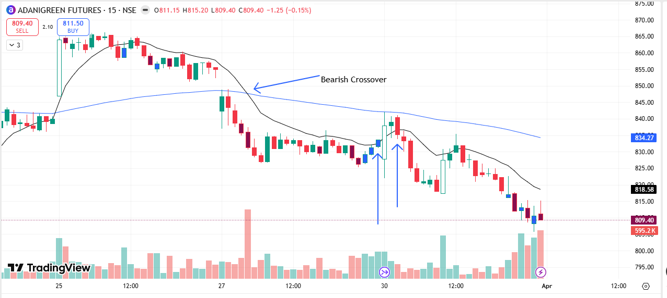
🟢 BULLISH SIGNAL --- DMART

Nifty Bias : 🔴 SHORT — Counter Trend ⚠️
Crossover : 2026-03-25 09:30 (5 days ago)
Pullback : 2026-03-30 09:15
Low ₹3877 ≤ EMA9(Low) ₹3897.47
High ₹3922.5 (breakout level)
Confirm : 2026-03-30 09:45 (+2 candle)
Close ₹3922.9 > Pullback High ₹3922.5 (body breakout)
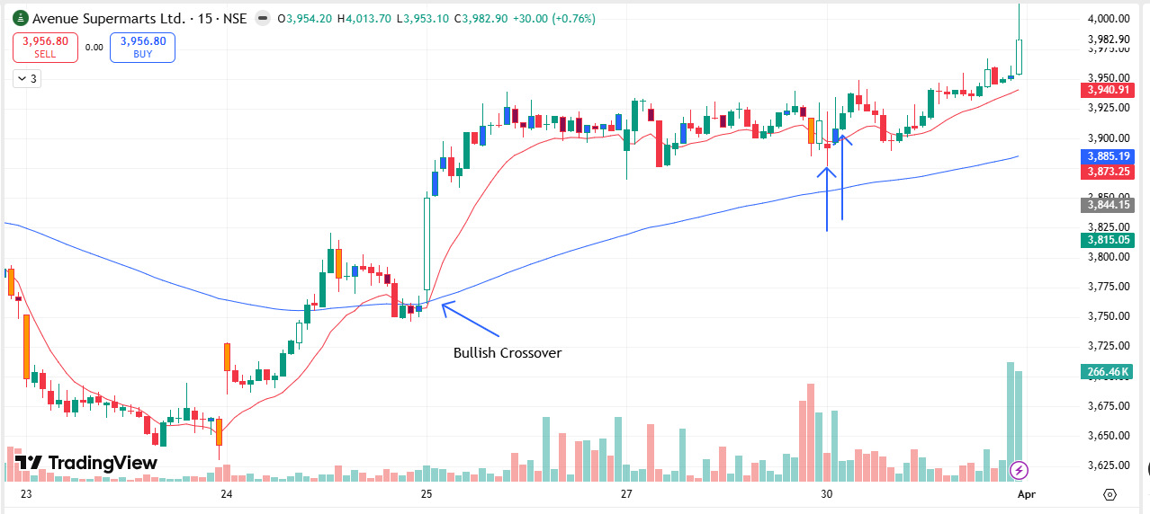
🔴 BEARISH SIGNAL --- BEL

Nifty Bias : 🔴 SHORT — Aligned ✅
Crossover : 2026-03-19 10:00 (11 days ago)
Pullback : 2026-03-30 09:30
High ₹413.25 ≥ EMA9(High) ₹409.81
Low ₹410.1 (breakdown level)
Confirm : 2026-03-30 09:45 (+1 candle)
Close ₹408.75 < Pullback Low ₹410.1 (body breakdown)
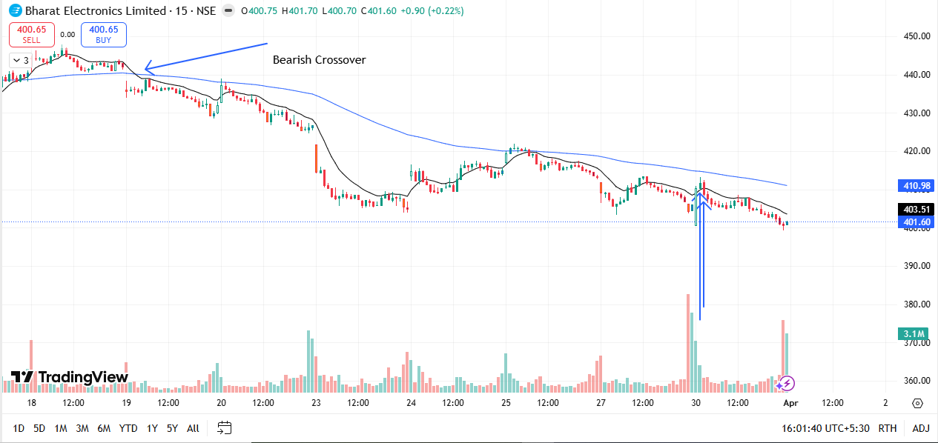
🔴 BEARISH SIGNAL --- CYIENT

Nifty Bias : 🔴 SHORT — Aligned ✅
Crossover : 2026-03-27 09:45 (3 days ago)
Pullback : 2026-03-30 09:30
High ₹793.95 ≥ EMA9(High) ₹793.39
Low ₹787.9 (breakdown level)
Confirm : 2026-03-30 09:45 (+1 candle)
Close ₹785.1 < Pullback Low ₹787.9 (body breakdown)
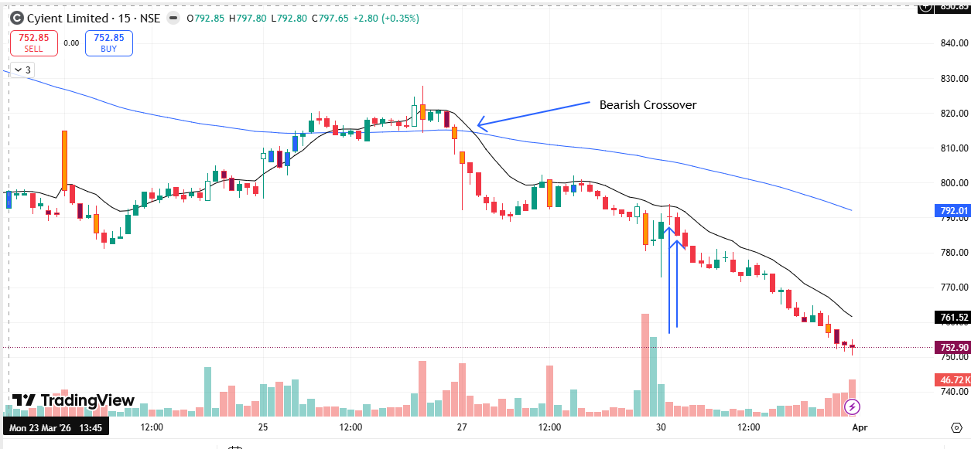
🟢 BULLISH SIGNAL --- SAMMAANCAP

Nifty Bias : 🔴 SHORT — Counter Trend ⚠️
Crossover : 2026-03-24 13:45 (6 days ago)
Pullback : 2026-03-27 15:15
Low ₹147.97 ≤ EMA9(Low) ₹148.24
High ₹149.5 (breakout level)
Confirm : 2026-03-30 09:45 (+3 candle)
Close ₹150.34 > Pullback High ₹149.5 (body breakout)
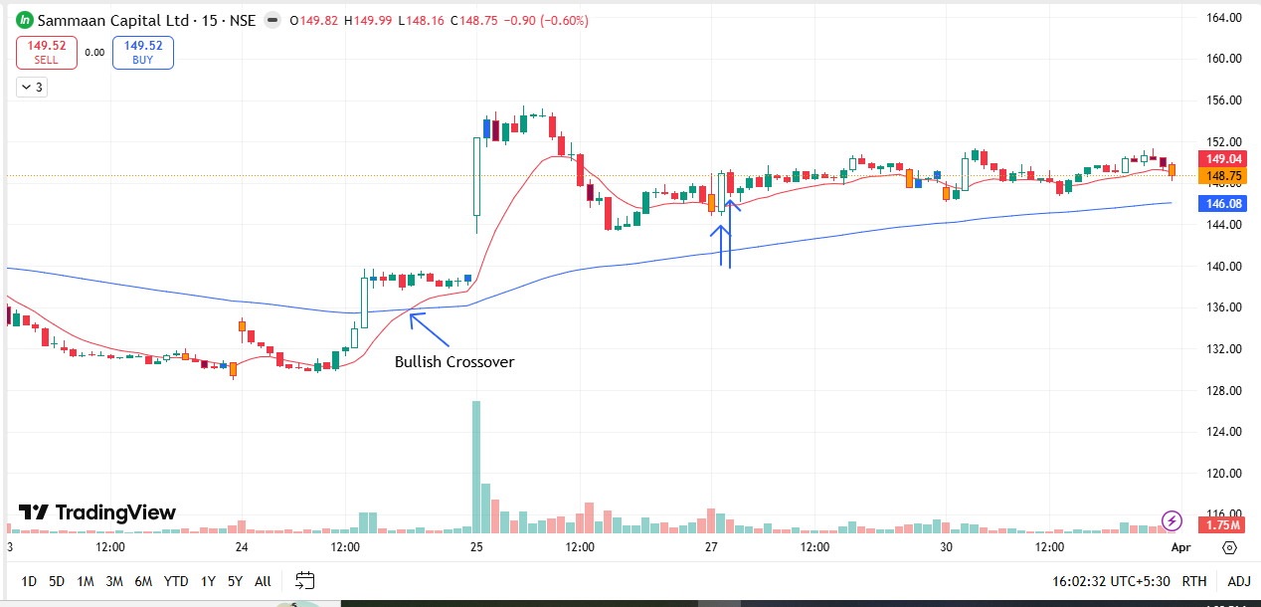
🔴 BEARISH SIGNAL --- SOLARINDS

Nifty Bias : 🔴 SHORT — Aligned ✅
Crossover : 2026-03-27 09:30 (3 days ago)
Pullback : 2026-03-27 15:15
High ₹12478 ≥ EMA9(High) ₹12477.42
Low ₹12398 (breakdown level)
Confirm : 2026-03-30 09:45 (+3 candle)
Close ₹12374 < Pullback Low ₹12398 (body breakdown)
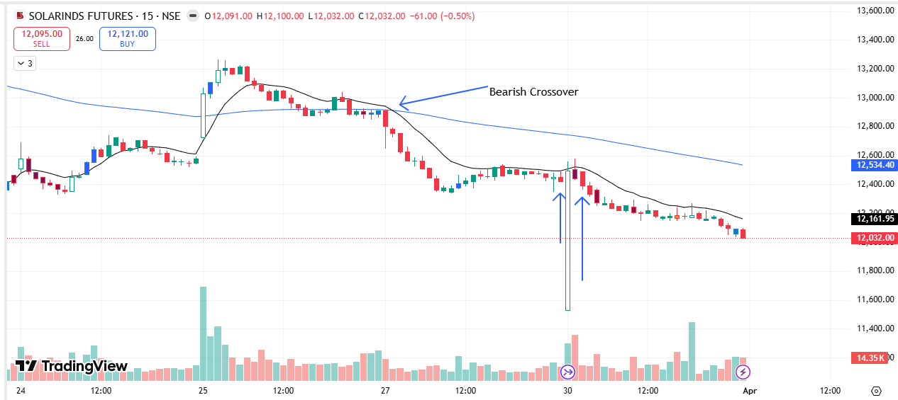
🔴 BEARISH SIGNAL --- CGPOWER

Nifty Bias : 🔴 SHORT — Aligned ✅
Crossover : 2026-03-27 11:00 (3 days ago)
Pullback : 2026-03-30 09:45
High ₹672.95 ≥ EMA9(High) ₹671.15
Low ₹665.15 (breakdown level)
Confirm : 2026-03-30 10:00 (+1 candle)
Close ₹662.4 < Pullback Low ₹665.15 (body breakdown)

🔴 BEARISH SIGNAL --- GAIL

Nifty Bias : 🔴 SHORT — Aligned ✅
Crossover : 2026-03-19 10:45 (11 days ago)
Pullback : 2026-03-30 09:45
High ₹139.63 ≥ EMA9(High) ₹138.67
Low ₹138.56 (breakdown level)
Confirm : 2026-03-30 10:00 (+1 candle)
Close ₹138.52 < Pullback Low ₹138.56 (body breakdown)
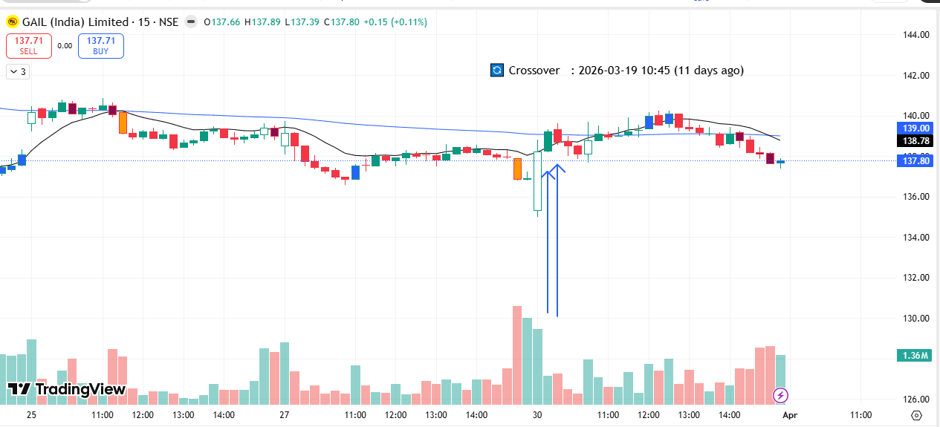
🔴 BEARISH SIGNAL --- HDFCLIFE

Nifty Bias : 🔴 SHORT — Aligned ✅
Crossover : 2026-03-30 09:30 (an hour ago)
Pullback : 2026-03-30 09:45
High ₹610 ≥ EMA9(High) ₹609.57
Low ₹604.05 (breakdown level)
Confirm : 2026-03-30 10:00 (+1 candle)
Close ₹603.2 < Pullback Low ₹604.05 (body breakdown)
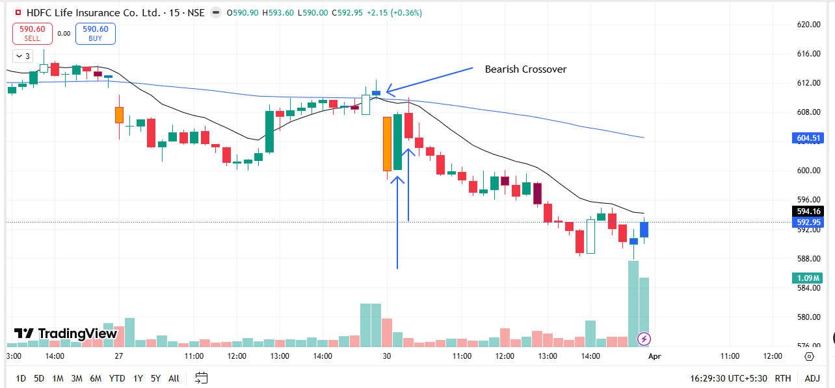
🔴 BEARISH SIGNAL --- IRCTC

Nifty Bias : 🔴 SHORT — Aligned ✅
Crossover : 2026-03-27 10:00 (3 days ago)
Pullback : 2026-03-30 09:30
High ₹512.25 ≥ EMA9(High) ₹511.97
Low ₹505.25 (breakdown level)
Confirm : 2026-03-30 10:00 (+2 candle)
Close ₹503.25 < Pullback Low ₹505.25 (body breakdown)
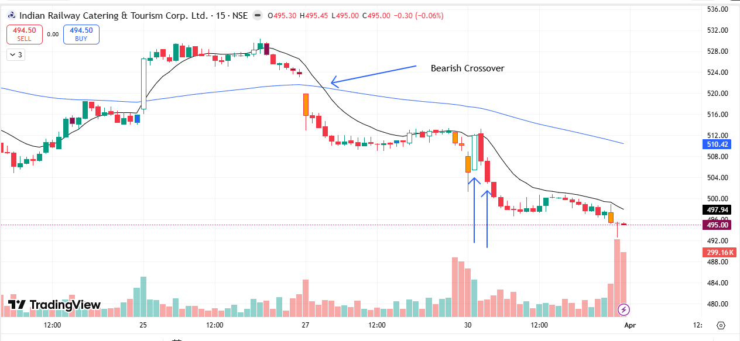
🔴 BEARISH SIGNAL --- LODHA

Nifty Bias : 🔴 SHORT — Aligned ✅
Crossover : 2026-03-19 09:30 (11 days ago)
Pullback : 2026-03-30 09:45
High ₹702.95 ≥ EMA9(High) ₹702.61
Low ₹692.3 (breakdown level)
Confirm : 2026-03-30 10:00 (+1 candle)
Close ₹686.35 < Pullback Low ₹692.3 (body breakdown)
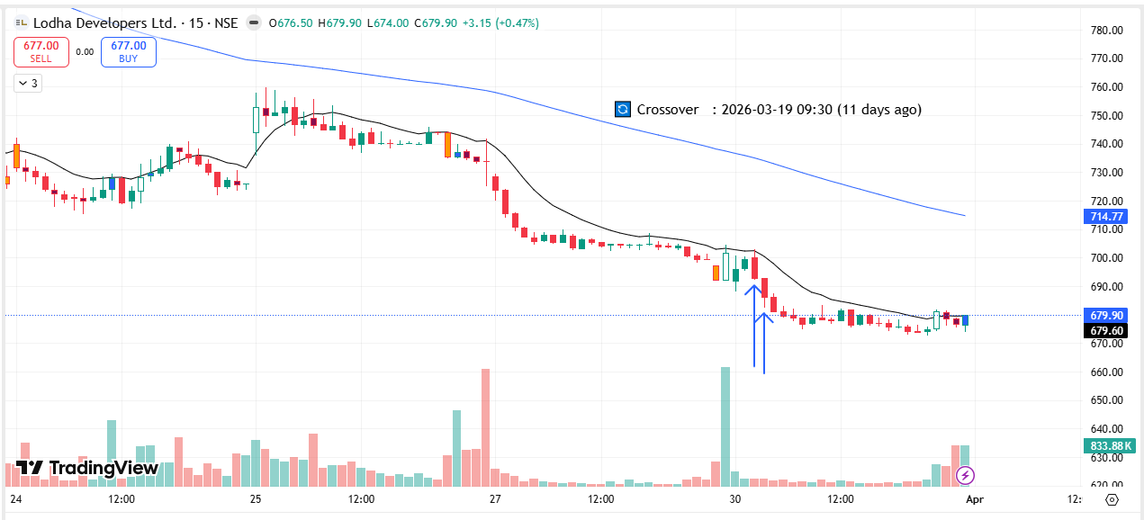
🔴 BEARISH SIGNAL --- NBCC

Nifty Bias : 🔴 SHORT — Aligned ✅
Crossover : 2026-03-27 10:45 (3 days ago)
Pullback : 2026-03-30 09:45
High ₹80.66 ≥ EMA9(High) ₹80.61
Low ₹79.95 (breakdown level)
Confirm : 2026-03-30 10:00 (+1 candle)
Close ₹79.56 < Pullback Low ₹79.95 (body breakdown)
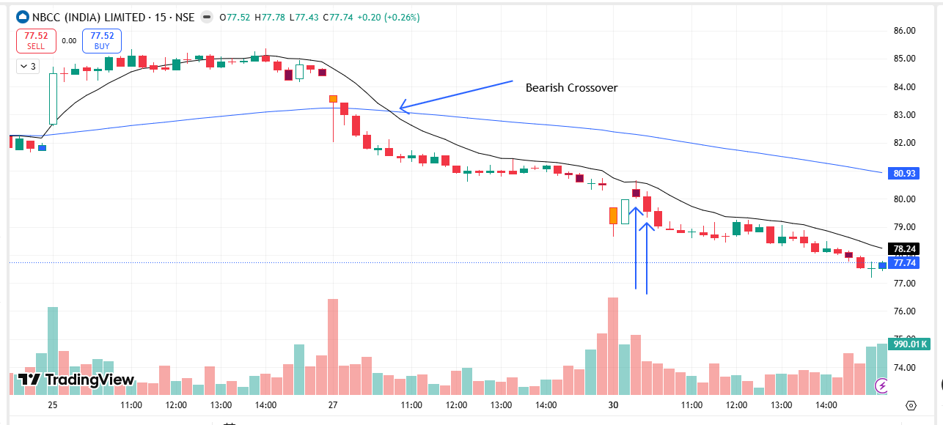
🔴 BEARISH SIGNAL --- NCC

Nifty Bias : 🔴 SHORT — Aligned ✅
Crossover : 2026-03-27 10:00 (3 days ago)
Pullback : 2026-03-30 09:30
High ₹137.5 ≥ EMA9(High) ₹137.06
Low ₹135.92 (breakdown level)
Confirm : 2026-03-30 10:00 (+2 candle)
Close ₹135.5 < Pullback Low ₹135.92 (body breakdown)
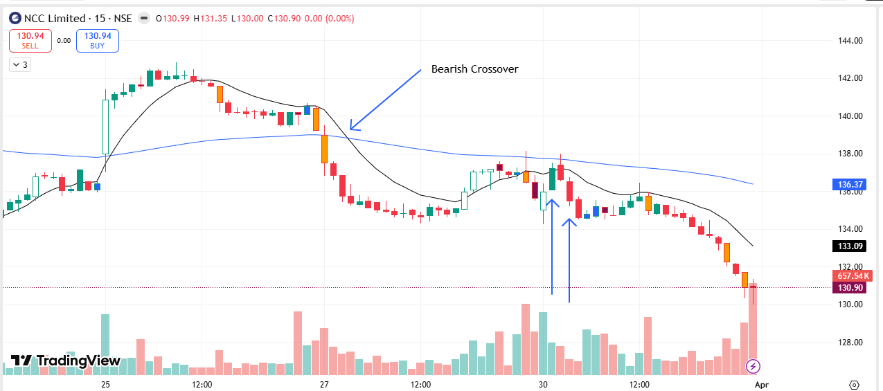
🔴 BEARISH SIGNAL --- PGEL

Nifty Bias : 🔴 SHORT — Aligned ✅
Crossover : 2026-03-27 11:00 (3 days ago)
Pullback : 2026-03-30 09:45
High ₹494.7 ≥ EMA9(High) ₹493.08
Low ₹485.8 (breakdown level)
Confirm : 2026-03-30 10:00 (+1 candle)
Close ₹484.45 < Pullback Low ₹485.8 (body breakdown)
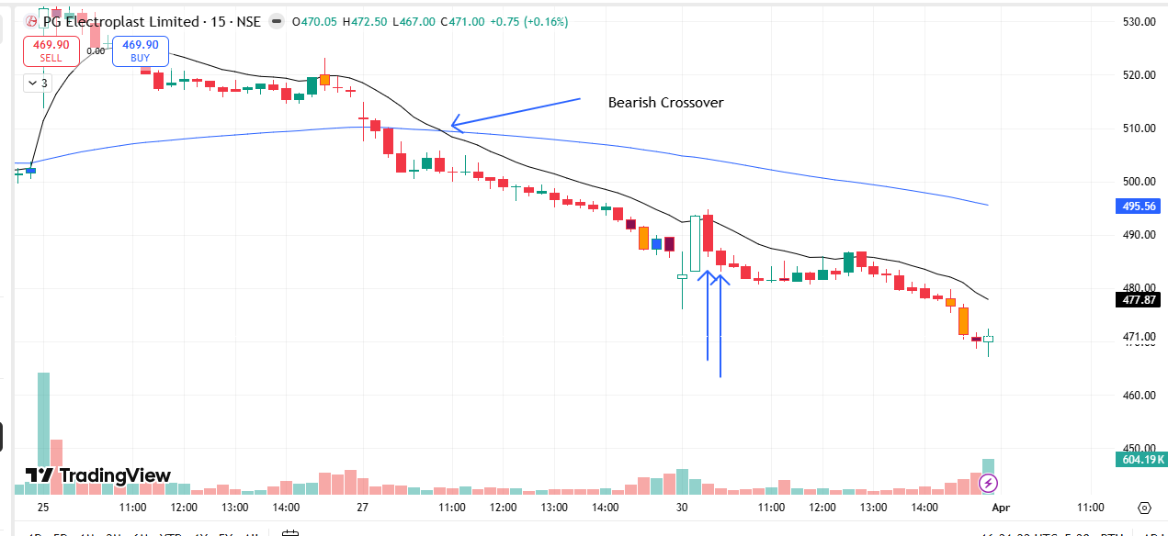
🔴 BEARISH SIGNAL --- POWERGRID

Nifty Bias : 🔴 SHORT — Aligned ✅
Crossover : 2026-03-25 13:30 (5 days ago)
Pullback : 2026-03-30 09:30
High ₹297.9 ≥ EMA9(High) ₹296.64
Low ₹295.7 (breakdown level)
Confirm : 2026-03-30 10:00 (+2 candle)
Close ₹295.5 < Pullback Low ₹295.7 (body breakdown)
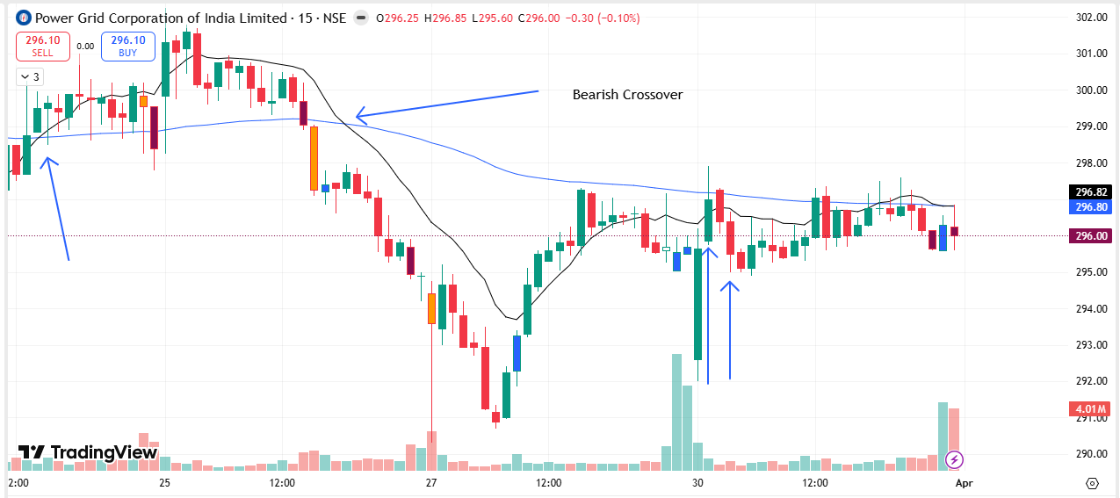
🔴 BEARISH SIGNAL --- TATAPOWER

Nifty Bias : 🔴 SHORT — Aligned ✅
Crossover : 2026-03-25 15:15 (5 days ago)
Pullback : 2026-03-30 09:30
High ₹388.75 ≥ EMA9(High) ₹388.38
Low ₹385.85 (breakdown level)
Confirm : 2026-03-30 10:00 (+2 candle)
Close ₹384.85 < Pullback Low ₹385.85 (body breakdown)
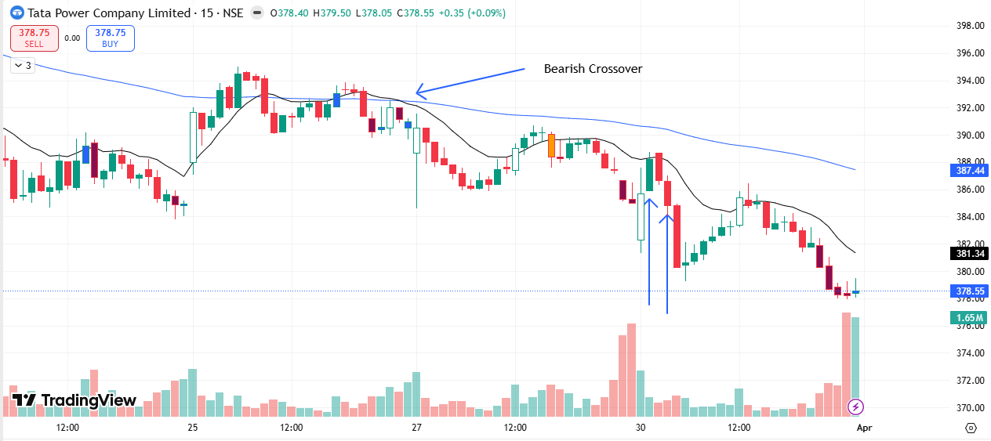
🔴 BEARISH SIGNAL --- BHEL

Nifty Bias : 🔴 SHORT — Aligned ✅
Crossover : 2026-03-27 11:00 (3 days ago)
Pullback : 2026-03-30 10:00
High ₹254.85 ≥ EMA9(High) ₹254.71
Low ₹252 (breakdown level)
Confirm : 2026-03-30 10:15 (+1 candle)
Close ₹251.25 < Pullback Low ₹252 (body breakdown)

🟢 BULLISH SIGNAL --- OFSS

Nifty Bias : 🔴 SHORT — Counter Trend ⚠️
Crossover : 2026-03-24 12:00 (6 days ago)
Pullback : 2026-03-30 10:00
Low ₹6743 ≤ EMA9(Low) ₹6819.73
High ₹6769.5 (breakout level)
Confirm : 2026-03-30 10:15 (+1 candle)
Close ₹6780 > Pullback High ₹6769.5 (body breakout)

🔴 BEARISH SIGNAL --- RELIANCE

Nifty Bias : 🔴 SHORT — Aligned ✅
Crossover : 2026-03-27 09:30 (3 days ago)
Pullback : 2026-03-30 09:30
High ₹1365 ≥ EMA9(High) ₹1356.71
Low ₹1355.7 (breakdown level)
Confirm : 2026-03-30 10:15 (+3 candle)
Close ₹1352.1 < Pullback Low ₹1355.7 (body breakdown)

🔴 BEARISH SIGNAL --- TMPV

Nifty Bias : 🔴 SHORT — Aligned ✅
Crossover : 2026-03-27 10:00 (3 days ago)
Pullback : 2026-03-30 09:45
High ₹303.5 ≥ EMA9(High) ₹303.04
Low ₹301.55 (breakdown level)
Confirm : 2026-03-30 10:15 (+2 candle)
Close ₹300.2 < Pullback Low ₹301.55 (body breakdown)

🔴 BEARISH SIGNAL --- TITAN

Nifty Bias : 🔴 SHORT — Aligned ✅
Crossover : 2026-03-27 15:00 (3 days ago)
Pullback : 2026-03-30 09:45
High ₹4007.4 ≥ EMA9(High) ₹3997.2
Low ₹3960.9 (breakdown level)
Confirm : 2026-03-30 10:15 (+2 candle)
Close ₹3953.3 < Pullback Low ₹3960.9 (body breakdown)

🔴 BEARISH SIGNAL --- AMBUJACEM

Nifty Bias : 🔴 SHORT — Aligned ✅
Crossover : 2026-03-27 10:30 (3 days ago)
Pullback : 2026-03-30 09:45
High ₹411 ≥ EMA9(High) ₹410.91
Low ₹408.8 (breakdown level)
Confirm : 2026-03-30 10:30 (+3 candle)
Close ₹408.75 < Pullback Low ₹408.8 (body breakdown)

🟢 BULLISH SIGNAL --- AUROPHARMA

Nifty Bias : 🔴 SHORT — Counter Trend ⚠️
Crossover : 2026-03-24 15:00 (6 days ago)
Pullback : 2026-03-30 10:15
Low ₹1302.3 ≤ EMA9(Low) ₹1306.57
High ₹1306.6 (breakout level)
Confirm : 2026-03-30 10:30 (+1 candle)
Close ₹1308.3 > Pullback High ₹1306.6 (body breakout)

🟢 BULLISH SIGNAL --- GLENMARK

Nifty Bias : 🔴 SHORT — Counter Trend ⚠️
Crossover : 2026-03-25 11:00 (5 days ago)
Pullback : 2026-03-30 10:15
Low ₹2147 ≤ EMA9(Low) ₹2156.72
High ₹2153.6 (breakout level)
Confirm : 2026-03-30 10:45 (+2 candle)
Close ₹2156.2 > Pullback High ₹2153.6 (body breakout)

🟢 BULLISH SIGNAL --- COALINDIA

Nifty Bias : 🔴 SHORT — Counter Trend ⚠️
Crossover : 2026-03-30 09:45 (2 hours ago)
Pullback : 2026-03-30 11:15
Low ₹450.7 ≤ EMA9(Low) ₹450.92
High ₹452.5 (breakout level)
Confirm : 2026-03-30 11:30 (+1 candle)
Close ₹454.6 > Pullback High ₹452.5 (body breakout)

🟢 BULLISH SIGNAL --- VEDL

Nifty Bias : 🔴 SHORT — Counter Trend ⚠️
Crossover : 2026-03-30 10:00 (2 hours ago)
Pullback : 2026-03-30 11:00
Low ₹660.3 ≤ EMA9(Low) ₹661.37
High ₹662.75 (breakout level)
Confirm : 2026-03-30 11:30 (+2 candle)
Close ₹662.8 > Pullback High ₹662.75 (body breakout)

🔴 BEARISH SIGNAL --- ASTRAL

Nifty Bias : 🔴 SHORT — Aligned ✅
Crossover : 2026-03-30 10:00 (3 hours ago)
Pullback : 2026-03-30 12:00
High ₹1626.4 ≥ EMA9(High) ₹1618.4
Low ₹1614.9 (breakdown level)
Confirm : 2026-03-30 12:15 (+1 candle)
Close ₹1612.4 < Pullback Low ₹1614.9 (body breakdown)

🔴 BEARISH SIGNAL --- IOC

Nifty Bias : 🔴 SHORT — Aligned ✅
Crossover : 2026-03-27 09:30 (3 days ago)
Pullback : 2026-03-30 12:00
High ₹137.43 ≥ EMA9(High) ₹137.32
Low ₹136.62 (breakdown level)
Confirm : 2026-03-30 12:15 (+1 candle)
Close ₹136.49 < Pullback Low ₹136.62 (body breakdown)

🔴 BEARISH SIGNAL --- INDIGO

Nifty Bias : 🔴 SHORT — Aligned ✅
Crossover : 2026-03-27 11:45 (3 days ago)
Pullback : 2026-03-30 11:30
High ₹4089.4 ≥ EMA9(High) ₹4083.83
Low ₹4075 (breakdown level)
Confirm : 2026-03-30 12:15 (+3 candle)
Close ₹4072 < Pullback Low ₹4075 (body breakdown)

🔴 BEARISH SIGNAL --- NTPC

Nifty Bias : 🔴 SHORT — Aligned ✅
Crossover : 2026-03-30 10:30 (2 hours ago)
Pullback : 2026-03-30 12:00
High ₹376.35 ≥ EMA9(High) ₹376.1
Low ₹375.3 (breakdown level)
Confirm : 2026-03-30 12:15 (+1 candle)
Close ₹375.1 < Pullback Low ₹375.3 (body breakdown)

🔴 BEARISH SIGNAL --- RECLTD

Nifty Bias : 🔴 SHORT — Aligned ✅
Crossover : 2026-03-27 10:30 (3 days ago)
Pullback : 2026-03-30 12:00
High ₹313.9 ≥ EMA9(High) ₹313.9
Low ₹312 (breakdown level)
Confirm : 2026-03-30 12:15 (+1 candle)
Close ₹311.55 < Pullback Low ₹312 (body breakdown)

🔴 BEARISH SIGNAL --- SHRIRAMFIN

Nifty Bias : 🔴 SHORT — Aligned ✅
Crossover : 2026-03-27 10:15 (3 days ago)
Pullback : 2026-03-30 12:00
High ₹882 ≥ EMA9(High) ₹881.91
Low ₹877.2 (breakdown level)
Confirm : 2026-03-30 12:15 (+1 candle)
Close ₹876.8 < Pullback Low ₹877.2 (body breakdown)

🔴 BEARISH SIGNAL --- ADANIENSOL

Nifty Bias : 🔴 SHORT — Aligned ✅
Crossover : 2026-03-27 10:45 (3 days ago)
Pullback : 2026-03-30 12:00
High ₹949 ≥ EMA9(High) ₹945.72
Low ₹941.6 (breakdown level)
Confirm : 2026-03-30 12:15 (+1 candle)
Close ₹937.2 < Pullback Low ₹941.6 (body breakdown)

🔴 BEARISH SIGNAL --- ANGELONE

Nifty Bias : 🔴 SHORT — Aligned ✅
Crossover : 2026-03-30 11:00 (2 hours ago)
Pullback : 2026-03-30 12:00
High ₹232.8 ≥ EMA9(High) ₹232.56
Low ₹231.17 (breakdown level)
Confirm : 2026-03-30 12:30 (+2 candle)
Close ₹230.62 < Pullback Low ₹231.17 (body breakdown)

🔴 BEARISH SIGNAL --- GRASIM

Nifty Bias : 🔴 SHORT — Aligned ✅
Crossover : 2026-03-30 10:15 (3 hours ago)
Pullback : 2026-03-30 12:00
High ₹2594.9 ≥ EMA9(High) ₹2587.71
Low ₹2579.8 (breakdown level)
Confirm : 2026-03-30 12:30 (+2 candle)
Close ₹2578.6 < Pullback Low ₹2579.8 (body breakdown)

🔴 BEARISH SIGNAL --- MANKIND

Nifty Bias : 🔴 SHORT — Aligned ✅
Crossover : 2026-03-30 11:15 (2 hours ago)
Pullback : 2026-03-30 12:00
High ₹2014.3 ≥ EMA9(High) ₹2009.29
Low ₹2006 (breakdown level)
Confirm : 2026-03-30 12:30 (+2 candle)
Close ₹2003.5 < Pullback Low ₹2006 (body breakdown)

🔴 BEARISH SIGNAL --- ALKEM

Nifty Bias : 🔴 SHORT — Aligned ✅
Crossover : 2026-03-30 10:00 (3 hours ago)
Pullback : 2026-03-30 12:30
High ₹5330 ≥ EMA9(High) ₹5316.44
Low ₹5316 (breakdown level)
Confirm : 2026-03-30 12:45 (+1 candle)
Close ₹5315.5 < Pullback Low ₹5316 (body breakdown)

🔴 BEARISH SIGNAL --- APOLLOHOSP

Nifty Bias : 🔴 SHORT — Aligned ✅
Crossover : 2026-03-30 10:45 (2 hours ago)
Pullback : 2026-03-30 12:15
High ₹7440.5 ≥ EMA9(High) ₹7433.09
Low ₹7404 (breakdown level)
Confirm : 2026-03-30 12:45 (+2 candle)
Close ₹7388.5 < Pullback Low ₹7404 (body breakdown)

🔴 BEARISH SIGNAL --- BLUESTARCO

Nifty Bias : 🔴 SHORT — Aligned ✅
Crossover : 2026-03-27 11:45 (3 days ago)
Pullback : 2026-03-30 12:30
High ₹1633.3 ≥ EMA9(High) ₹1631.23
Low ₹1628.7 (breakdown level)
Confirm : 2026-03-30 12:45 (+1 candle)
Close ₹1621.1 < Pullback Low ₹1628.7 (body breakdown)

🔴 BEARISH SIGNAL --- CIPLA

Nifty Bias : 🔴 SHORT — Aligned ✅
Crossover : 2026-03-30 09:15 (4 hours ago)
Pullback : 2026-03-30 12:15
High ₹1233.1 ≥ EMA9(High) ₹1231.15
Low ₹1229.6 (breakdown level)
Confirm : 2026-03-30 12:45 (+2 candle)
Close ₹1227.8 < Pullback Low ₹1229.6 (body breakdown)

🔴 BEARISH SIGNAL --- DELHIVERY

Nifty Bias : 🔴 SHORT — Aligned ✅
Crossover : 2026-03-30 10:30 (3 hours ago)
Pullback : 2026-03-30 12:00
High ₹420 ≥ EMA9(High) ₹419.57
Low ₹417.7 (breakdown level)
Confirm : 2026-03-30 12:45 (+3 candle)
Close ₹417.55 < Pullback Low ₹417.7 (body breakdown)

🔴 BEARISH SIGNAL --- DIXON

Nifty Bias : 🔴 SHORT — Aligned ✅
Crossover : 2026-03-27 10:30 (3 days ago)
Pullback : 2026-03-30 12:00
High ₹9980 ≥ EMA9(High) ₹9944.08
Low ₹9909 (breakdown level)
Confirm : 2026-03-30 12:45 (+3 candle)
Close ₹9892 < Pullback Low ₹9909 (body breakdown)

🔴 BEARISH SIGNAL --- DRREDDY

Nifty Bias : 🔴 SHORT — Aligned ✅
Crossover : 2026-03-30 09:45 (3 hours ago)
Pullback : 2026-03-30 12:00
High ₹1271.3 ≥ EMA9(High) ₹1266.49
Low ₹1262.9 (breakdown level)
Confirm : 2026-03-30 12:45 (+3 candle)
Close ₹1259.2 < Pullback Low ₹1262.9 (body breakdown)

🔴 BEARISH SIGNAL --- HEROMOTOCO

Nifty Bias : 🔴 SHORT — Aligned ✅
Crossover : 2026-03-27 10:00 (3 days ago)
Pullback : 2026-03-30 12:00
High ₹5140 ≥ EMA9(High) ₹5120.65
Low ₹5113.5 (breakdown level)
Confirm : 2026-03-30 12:45 (+3 candle)
Close ₹5101.5 < Pullback Low ₹5113.5 (body breakdown)

🔴 BEARISH SIGNAL --- HINDZINC

Nifty Bias : 🔴 SHORT — Aligned ✅
Crossover : 2026-03-30 10:45 (2 hours ago)
Pullback : 2026-03-30 12:00
High ₹510.9 ≥ EMA9(High) ₹509.79
Low ₹508.5 (breakdown level)
Confirm : 2026-03-30 12:45 (+3 candle)
Close ₹507.05 < Pullback Low ₹508.5 (body breakdown)

🔴 BEARISH SIGNAL --- ICICIGI

Nifty Bias : 🔴 SHORT — Aligned ✅
Crossover : 2026-03-27 10:45 (3 days ago)
Pullback : 2026-03-30 12:15
High ₹1720.4 ≥ EMA9(High) ₹1710.61
Low ₹1713 (breakdown level)
Confirm : 2026-03-30 12:45 (+2 candle)
Close ₹1712.7 < Pullback Low ₹1713 (body breakdown)

🔴 BEARISH SIGNAL --- INDIANB

Nifty Bias : 🔴 SHORT — Aligned ✅
Crossover : 2026-03-27 12:00 (3 days ago)
Pullback : 2026-03-30 12:15
High ₹862.8 ≥ EMA9(High) ₹859.43
Low ₹857 (breakdown level)
Confirm : 2026-03-30 12:45 (+2 candle)
Close ₹855.3 < Pullback Low ₹857 (body breakdown)

🔴 BEARISH SIGNAL --- NAUKRI

Nifty Bias : 🔴 SHORT — Aligned ✅
Crossover : 2026-03-30 09:30 (4 hours ago)
Pullback : 2026-03-30 12:15
High ₹967 ≥ EMA9(High) ₹965.73
Low ₹964.4 (breakdown level)
Confirm : 2026-03-30 12:45 (+2 candle)
Close ₹963.7 < Pullback Low ₹964.4 (body breakdown)

🔴 BEARISH SIGNAL --- INFY

Nifty Bias : 🔴 SHORT — Aligned ✅
Crossover : 2026-03-30 09:30 (4 hours ago)
Pullback : 2026-03-30 12:15
High ₹1264.5 ≥ EMA9(High) ₹1262.11
Low ₹1260.3 (breakdown level)
Confirm : 2026-03-30 12:45 (+2 candle)
Close ₹1258 < Pullback Low ₹1260.3 (body breakdown)

🔴 BEARISH SIGNAL --- INOXWIND

Nifty Bias : 🔴 SHORT — Aligned ✅
Crossover : 2026-03-27 14:45 (3 days ago)
Pullback : 2026-03-30 12:00
High ₹78.17 ≥ EMA9(High) ₹77.94
Low ₹77.56 (breakdown level)
Confirm : 2026-03-30 12:45 (+3 candle)
Close ₹77.43 < Pullback Low ₹77.56 (body breakdown)

🔴 BEARISH SIGNAL --- JSWENERGY

Nifty Bias : 🔴 SHORT — Aligned ✅
Crossover : 2026-03-27 10:15 (3 days ago)
Pullback : 2026-03-30 12:00
High ₹477.55 ≥ EMA9(High) ₹476.96
Low ₹473.85 (breakdown level)
Confirm : 2026-03-30 12:45 (+3 candle)
Close ₹472.5 < Pullback Low ₹473.85 (body breakdown)

🔴 BEARISH SIGNAL --- MARICO

Nifty Bias : 🔴 SHORT — Aligned ✅
Crossover : 2026-03-30 11:00 (2 hours ago)
Pullback : 2026-03-30 12:15
High ₹744.5 ≥ EMA9(High) ₹743.3
Low ₹741 (breakdown level)
Confirm : 2026-03-30 12:45 (+2 candle)
Close ₹740.9 < Pullback Low ₹741 (body breakdown)

🔴 BEARISH SIGNAL --- MAXHEALTH

Nifty Bias : 🔴 SHORT — Aligned ✅
Crossover : 2026-03-30 09:45 (3 hours ago)
Pullback : 2026-03-30 12:30
High ₹962.7 ≥ EMA9(High) ₹959.23
Low ₹959.6 (breakdown level)
Confirm : 2026-03-30 12:45 (+1 candle)
Close ₹959.4 < Pullback Low ₹959.6 (body breakdown)

🔴 BEARISH SIGNAL --- NESTLEIND

Nifty Bias : 🔴 SHORT — Aligned ✅
Crossover : 2026-03-30 10:00 (3 hours ago)
Pullback : 2026-03-30 12:15
High ₹1187.5 ≥ EMA9(High) ₹1187.11
Low ₹1182.7 (breakdown level)
Confirm : 2026-03-30 12:45 (+2 candle)
Close ₹1182.5 < Pullback Low ₹1182.7 (body breakdown)

🔴 BEARISH SIGNAL --- SUNPHARMA

Nifty Bias : 🔴 SHORT — Aligned ✅
Crossover : 2026-03-30 10:45 (2 hours ago)
Pullback : 2026-03-30 12:00
High ₹1783 ≥ EMA9(High) ₹1781.98
Low ₹1777.1 (breakdown level)
Confirm : 2026-03-30 12:45 (+3 candle)
Close ₹1775 < Pullback Low ₹1777.1 (body breakdown)

🔴 BEARISH SIGNAL --- TCS

Nifty Bias : 🔴 SHORT — Aligned ✅
Crossover : 2026-03-27 15:15 (3 days ago)
Pullback : 2026-03-30 12:15
High ₹2394.5 ≥ EMA9(High) ₹2384.92
Low ₹2388.3 (breakdown level)
Confirm : 2026-03-30 12:45 (+2 candle)
Close ₹2385.9 < Pullback Low ₹2388.3 (body breakdown)

🔴 BEARISH SIGNAL --- INDHOTEL

Nifty Bias : 🔴 SHORT — Aligned ✅
Crossover : 2026-03-27 11:45 (3 days ago)
Pullback : 2026-03-30 12:15
High ₹584.25 ≥ EMA9(High) ₹582.86
Low ₹581.65 (breakdown level)
Confirm : 2026-03-30 12:45 (+2 candle)
Close ₹580.2 < Pullback Low ₹581.65 (body breakdown)

🔴 BEARISH SIGNAL --- TIINDIA

Nifty Bias : 🔴 SHORT — Aligned ✅
Crossover : 2026-03-27 15:15 (3 days ago)
Pullback : 2026-03-30 12:00
High ₹2549.1 ≥ EMA9(High) ₹2544.22
Low ₹2525.6 (breakdown level)
Confirm : 2026-03-30 12:45 (+3 candle)
Close ₹2524.6 < Pullback Low ₹2525.6 (body breakdown)

🔴 BEARISH SIGNAL --- UNITDSPR

Nifty Bias : 🔴 SHORT — Aligned ✅
Crossover : 2026-03-27 10:00 (3 days ago)
Pullback : 2026-03-30 12:00
High ₹1238.9 ≥ EMA9(High) ₹1237.97
Low ₹1229.8 (breakdown level)
Confirm : 2026-03-30 12:45 (+3 candle)
Close ₹1228.3 < Pullback Low ₹1229.8 (body breakdown)

🔴 BEARISH SIGNAL --- ABB

Nifty Bias : 🔴 SHORT — Aligned ✅
Crossover : 2026-03-27 09:30 (3 days ago)
Pullback : 2026-03-30 12:45
High ₹6035.5 ≥ EMA9(High) ₹6023.65
Low ₹6008 (breakdown level)
Confirm : 2026-03-30 13:00 (+1 candle)
Close ₹6000 < Pullback Low ₹6008 (body breakdown)

🔴 BEARISH SIGNAL --- GODREJCP

Nifty Bias : 🔴 SHORT — Aligned ✅
Crossover : 2026-03-27 11:45 (3 days ago)
Pullback : 2026-03-30 12:30
High ₹996.8 ≥ EMA9(High) ₹995.63
Low ₹993 (breakdown level)
Confirm : 2026-03-30 13:00 (+2 candle)
Close ₹992.6 < Pullback Low ₹993 (body breakdown)

🔴 BEARISH SIGNAL --- HCLTECH

Nifty Bias : 🔴 SHORT — Aligned ✅
Crossover : 2026-03-27 15:15 (3 days ago)
Pullback : 2026-03-30 12:15
High ₹1357.4 ≥ EMA9(High) ₹1354.49
Low ₹1353.6 (breakdown level)
Confirm : 2026-03-30 13:00 (+3 candle)
Close ₹1353.5 < Pullback Low ₹1353.6 (body breakdown)

🔴 BEARISH SIGNAL --- ICICIBANK

Nifty Bias : 🔴 SHORT — Aligned ✅
Crossover : 2026-03-27 13:30 (3 days ago)
Pullback : 2026-03-30 12:45
High ₹1220.8 ≥ EMA9(High) ₹1220.4
Low ₹1216.4 (breakdown level)
Confirm : 2026-03-30 13:00 (+1 candle)
Close ₹1215.9 < Pullback Low ₹1216.4 (body breakdown)

🔴 BEARISH SIGNAL --- JINDALSTEL

Nifty Bias : 🔴 SHORT — Aligned ✅
Crossover : 2026-03-30 09:30 (4 hours ago)
Pullback : 2026-03-30 12:15
High ₹1125.4 ≥ EMA9(High) ₹1121.86
Low ₹1117.4 (breakdown level)
Confirm : 2026-03-30 13:00 (+3 candle)
Close ₹1115.5 < Pullback Low ₹1117.4 (body breakdown)

🔴 BEARISH SIGNAL --- PAGEIND

Nifty Bias : 🔴 SHORT — Aligned ✅
Crossover : 2026-03-27 14:30 (3 days ago)
Pullback : 2026-03-30 12:30
High ₹31895 ≥ EMA9(High) ₹31828.54
Low ₹31770 (breakdown level)
Confirm : 2026-03-30 13:00 (+2 candle)
Close ₹31735 < Pullback Low ₹31770 (body breakdown)

🔴 BEARISH SIGNAL --- PIDILITIND

Nifty Bias : 🔴 SHORT — Aligned ✅
Crossover : 2026-03-27 11:00 (3 days ago)
Pullback : 2026-03-30 12:45
High ₹1294.3 ≥ EMA9(High) ₹1292.87
Low ₹1291.7 (breakdown level)
Confirm : 2026-03-30 13:00 (+1 candle)
Close ₹1290.2 < Pullback Low ₹1291.7 (body breakdown)

🔴 BEARISH SIGNAL --- SYNGENE

Nifty Bias : 🔴 SHORT — Aligned ✅
Crossover : 2026-03-30 09:45 (4 hours ago)
Pullback : 2026-03-30 12:45
High ₹404 ≥ EMA9(High) ₹400.99
Low ₹400.65 (breakdown level)
Confirm : 2026-03-30 13:00 (+1 candle)
Close ₹397.7 < Pullback Low ₹400.65 (body breakdown)

🔴 BEARISH SIGNAL --- CAMS

Nifty Bias : 🔴 SHORT — Aligned ✅
Crossover : 2026-03-30 09:15 (4 hours ago)
Pullback : 2026-03-30 12:45
High ₹631.8 ≥ EMA9(High) ₹629.98
Low ₹628.2 (breakdown level)
Confirm : 2026-03-30 13:15 (+2 candle)
Close ₹627.75 < Pullback Low ₹628.2 (body breakdown)

🔴 BEARISH SIGNAL --- CROMPTON

Nifty Bias : 🔴 SHORT — Aligned ✅
Crossover : 2026-03-27 10:15 (3 days ago)
Pullback : 2026-03-30 13:00
High ₹228.5 ≥ EMA9(High) ₹227.58
Low ₹227.2 (breakdown level)
Confirm : 2026-03-30 13:15 (+1 candle)
Close ₹226.35 < Pullback Low ₹227.2 (body breakdown)

🔴 BEARISH SIGNAL --- POWERINDIA

Nifty Bias : 🔴 SHORT — Aligned ✅
Crossover : 2026-03-27 12:45 (3 days ago)
Pullback : 2026-03-30 12:45
High ₹24395 ≥ EMA9(High) ₹24367.94
Low ₹24290 (breakdown level)
Confirm : 2026-03-30 13:15 (+2 candle)
Close ₹24285 < Pullback Low ₹24290 (body breakdown)

🔴 BEARISH SIGNAL --- LT

Nifty Bias : 🔴 SHORT — Aligned ✅
Crossover : 2026-03-30 10:45 (3 hours ago)
Pullback : 2026-03-30 12:30
High ₹3541.6 ≥ EMA9(High) ₹3530.98
Low ₹3525 (breakdown level)
Confirm : 2026-03-30 13:15 (+3 candle)
Close ₹3515.6 < Pullback Low ₹3525 (body breakdown)

🔴 BEARISH SIGNAL --- LUPIN

Nifty Bias : 🔴 SHORT — Aligned ✅
Crossover : 2026-03-30 10:15 (3 hours ago)
Pullback : 2026-03-30 12:30
High ₹2330.4 ≥ EMA9(High) ₹2320.02
Low ₹2321.2 (breakdown level)
Confirm : 2026-03-30 13:15 (+3 candle)
Close ₹2319.1 < Pullback Low ₹2321.2 (body breakdown)

🔴 BEARISH SIGNAL --- MPHASIS

Nifty Bias : 🔴 SHORT — Aligned ✅
Crossover : 2026-03-30 09:30 (4 hours ago)
Pullback : 2026-03-30 12:30
High ₹2076.9 ≥ EMA9(High) ₹2074.57
Low ₹2066.9 (breakdown level)
Confirm : 2026-03-30 13:15 (+3 candle)
Close ₹2060 < Pullback Low ₹2066.9 (body breakdown)

🔴 BEARISH SIGNAL --- RBLBANK

Nifty Bias : 🔴 SHORT — Aligned ✅
Crossover : 2026-03-27 11:45 (3 days ago)
Pullback : 2026-03-30 12:30
High ₹294.4 ≥ EMA9(High) ₹294.18
Low ₹293.05 (breakdown level)
Confirm : 2026-03-30 13:15 (+3 candle)
Close ₹292.95 < Pullback Low ₹293.05 (body breakdown)

🔴 BEARISH SIGNAL --- SUZLON

Nifty Bias : 🔴 SHORT — Aligned ✅
Crossover : 2026-03-27 11:15 (3 days ago)
Pullback : 2026-03-30 12:30
High ₹40.28 ≥ EMA9(High) ₹40.24
Low ₹40.01 (breakdown level)
Confirm : 2026-03-30 13:15 (+3 candle)
Close ₹39.96 < Pullback Low ₹40.01 (body breakdown)

🔴 BEARISH SIGNAL --- APLAPOLLO

Nifty Bias : 🔴 SHORT — Aligned ✅
Crossover : 2026-03-30 10:30 (3 hours ago)
Pullback : 2026-03-30 13:15
High ₹1971.5 ≥ EMA9(High) ₹1967.34
Low ₹1966 (breakdown level)
Confirm : 2026-03-30 13:30 (+1 candle)
Close ₹1965.7 < Pullback Low ₹1966 (body breakdown)

🔴 BEARISH SIGNAL --- BIOCON

Nifty Bias : 🔴 SHORT — Aligned ✅
Crossover : 2026-03-27 11:30 (3 days ago)
Pullback : 2026-03-30 13:15
High ₹362.7 ≥ EMA9(High) ₹362.42
Low ₹362.05 (breakdown level)
Confirm : 2026-03-30 13:30 (+1 candle)
Close ₹362 < Pullback Low ₹362.05 (body breakdown)

🟢 BULLISH SIGNAL --- HINDALCO

Nifty Bias : 🔴 SHORT — Counter Trend ⚠️
Crossover : 2026-03-30 09:30 (4 hours ago)
Pullback : 2026-03-30 13:00
Low ₹886.4 ≤ EMA9(Low) ₹889.25
High ₹889.9 (breakout level)
Confirm : 2026-03-30 13:30 (+2 candle)
Close ₹890.4 > Pullback High ₹889.9 (body breakout)

🔴 BEARISH SIGNAL --- MCX

Nifty Bias : 🔴 SHORT — Aligned ✅
Crossover : 2026-03-27 12:15 (3 days ago)
Pullback : 2026-03-30 13:15
High ₹2413 ≥ EMA9(High) ₹2398.07
Low ₹2404 (breakdown level)
Confirm : 2026-03-30 13:30 (+1 candle)
Close ₹2401 < Pullback Low ₹2404 (body breakdown)

🔴 BEARISH SIGNAL --- ASHOKLEY

Nifty Bias : 🔴 SHORT — Aligned ✅
Crossover : 2026-03-27 10:00 (3 days ago)
Pullback : 2026-03-30 13:30
High ₹156.79 ≥ EMA9(High) ₹156.63
Low ₹155.95 (breakdown level)
Confirm : 2026-03-30 13:45 (+1 candle)
Close ₹155.91 < Pullback Low ₹155.95 (body breakdown)

🔴 BEARISH SIGNAL --- BHARATFORG

Nifty Bias : 🔴 SHORT — Aligned ✅
Crossover : 2026-03-30 10:15 (4 hours ago)
Pullback : 2026-03-30 13:15
High ₹1688.5 ≥ EMA9(High) ₹1686.28
Low ₹1682.6 (breakdown level)
Confirm : 2026-03-30 13:45 (+2 candle)
Close ₹1676.3 < Pullback Low ₹1682.6 (body breakdown)

🔴 BEARISH SIGNAL --- CUMMINSIND

Nifty Bias : 🔴 SHORT — Aligned ✅
Crossover : 2026-03-30 10:15 (4 hours ago)
Pullback : 2026-03-30 13:00
High ₹4571.9 ≥ EMA9(High) ₹4557.99
Low ₹4546 (breakdown level)
Confirm : 2026-03-30 13:45 (+3 candle)
Close ₹4541 < Pullback Low ₹4546 (body breakdown)

🔴 BEARISH SIGNAL --- FORTIS

Nifty Bias : 🔴 SHORT — Aligned ✅
Crossover : 2026-03-30 09:15 (5 hours ago)
Pullback : 2026-03-30 13:15
High ₹802 ≥ EMA9(High) ₹799.89
Low ₹800 (breakdown level)
Confirm : 2026-03-30 13:45 (+2 candle)
Close ₹798.15 < Pullback Low ₹800 (body breakdown)

🔴 BEARISH SIGNAL --- JSWSTEEL

Nifty Bias : 🔴 SHORT — Aligned ✅
Crossover : 2026-03-27 12:15 (3 days ago)
Pullback : 2026-03-30 13:00
High ₹1131.9 ≥ EMA9(High) ₹1131.14
Low ₹1128.3 (breakdown level)
Confirm : 2026-03-30 13:45 (+3 candle)
Close ₹1128.2 < Pullback Low ₹1128.3 (body breakdown)

🔴 BEARISH SIGNAL --- SRF

Nifty Bias : 🔴 SHORT — Aligned ✅
Crossover : 2026-03-30 09:30 (5 hours ago)
Pullback : 2026-03-30 13:15
High ₹2453.6 ≥ EMA9(High) ₹2451.21
Low ₹2442.9 (breakdown level)
Confirm : 2026-03-30 13:45 (+2 candle)
Close ₹2441.5 < Pullback Low ₹2442.9 (body breakdown)

🔴 BEARISH SIGNAL --- SUPREMEIND

Nifty Bias : 🔴 SHORT — Aligned ✅
Crossover : 2026-03-27 10:45 (3 days ago)
Pullback : 2026-03-30 13:30
High ₹3749.3 ≥ EMA9(High) ₹3731.91
Low ₹3725 (breakdown level)
Confirm : 2026-03-30 13:45 (+1 candle)
Close ₹3718 < Pullback Low ₹3725 (body breakdown)

🔴 BEARISH SIGNAL --- TITAGARH

Nifty Bias : 🔴 SHORT — Aligned ✅
Crossover : 2026-03-27 10:15 (3 days ago)
Pullback : 2026-03-30 13:30
High ₹589.15 ≥ EMA9(High) ₹582.05
Low ₹585 (breakdown level)
Confirm : 2026-03-30 13:45 (+1 candle)
Close ₹584.75 < Pullback Low ₹585 (body breakdown)

🔴 BEARISH SIGNAL --- PHOENIXLTD

Nifty Bias : 🔴 SHORT — Aligned ✅
Crossover : 2026-03-27 10:45 (3 days ago)
Pullback : 2026-03-30 13:00
High ₹1523.6 ≥ EMA9(High) ₹1517.61
Low ₹1512.1 (breakdown level)
Confirm : 2026-03-30 13:45 (+3 candle)
Close ₹1511.7 < Pullback Low ₹1512.1 (body breakdown)

🔴 BEARISH SIGNAL --- VOLTAS

Nifty Bias : 🔴 SHORT — Aligned ✅
Crossover : 2026-03-30 09:15 (5 hours ago)
Pullback : 2026-03-30 13:30
High ₹1286.3 ≥ EMA9(High) ₹1286.27
Low ₹1277.6 (breakdown level)
Confirm : 2026-03-30 13:45 (+1 candle)
Close ₹1276.4 < Pullback Low ₹1277.6 (body breakdown)

🔴 BEARISH SIGNAL --- BAJAJ-AUTO

Nifty Bias : 🔴 SHORT — Aligned ✅
Crossover : 2026-03-27 10:15 (3 days ago)
Pullback : 2026-03-30 13:30
High ₹8867 ≥ EMA9(High) ₹8852.08
Low ₹8821 (breakdown level)
Confirm : 2026-03-30 14:00 (+2 candle)
Close ₹8802 < Pullback Low ₹8821 (body breakdown)

🔴 BEARISH SIGNAL --- BSE

Nifty Bias : 🔴 SHORT — Aligned ✅
Crossover : 2026-03-27 14:45 (3 days ago)
Pullback : 2026-03-30 14:00
High ₹2720 ≥ EMA9(High) ₹2719.78
Low ₹2709 (breakdown level)
Confirm : 2026-03-30 14:15 (+1 candle)
Close ₹2705.6 < Pullback Low ₹2709 (body breakdown)

🔴 BEARISH SIGNAL --- INDUSTOWER

Nifty Bias : 🔴 SHORT — Aligned ✅
Crossover : 2026-03-30 09:30 (5 hours ago)
Pullback : 2026-03-30 13:30
High ₹423.8 ≥ EMA9(High) ₹421.4
Low ₹420.65 (breakdown level)
Confirm : 2026-03-30 14:15 (+3 candle)
Close ₹418.5 < Pullback Low ₹420.65 (body breakdown)

🔴 BEARISH SIGNAL --- SIEMENS

Nifty Bias : 🔴 SHORT — Aligned ✅
Crossover : 2026-03-30 09:15 (5 hours ago)
Pullback : 2026-03-30 14:00
High ₹2977.6 ≥ EMA9(High) ₹2973.74
Low ₹2956.4 (breakdown level)
Confirm : 2026-03-30 14:15 (+1 candle)
Close ₹2955.4 < Pullback Low ₹2956.4 (body breakdown)

🔴 BEARISH SIGNAL --- TORNTPHARM

Nifty Bias : 🔴 SHORT — Aligned ✅
Crossover : 2026-03-30 09:45 (5 hours ago)
Pullback : 2026-03-30 13:30
High ₹4244.8 ≥ EMA9(High) ₹4235.84
Low ₹4230.1 (breakdown level)
Confirm : 2026-03-30 14:15 (+3 candle)
Close ₹4226.5 < Pullback Low ₹4230.1 (body breakdown)

🔴 BEARISH SIGNAL --- VBL

Nifty Bias : 🔴 SHORT — Aligned ✅
Crossover : 2026-03-27 10:30 (3 days ago)
Pullback : 2026-03-30 14:00
High ₹387.9 ≥ EMA9(High) ₹386.96
Low ₹385.85 (breakdown level)
Confirm : 2026-03-30 14:15 (+1 candle)
Close ₹385.8 < Pullback Low ₹385.85 (body breakdown)

🔴 BEARISH SIGNAL --- 360ONE

Nifty Bias : 🔴 SHORT — Aligned ✅
Crossover : 2026-03-20 14:45 (10 days ago)
Pullback : 2026-03-30 14:00
High ₹953.6 ≥ EMA9(High) ₹949.35
Low ₹950.6 (breakdown level)
Confirm : 2026-03-30 14:30 (+2 candle)
Close ₹950.3 < Pullback Low ₹950.6 (body breakdown)

🔴 BEARISH SIGNAL --- M&M

Nifty Bias : 🔴 SHORT — Aligned ✅
Crossover : 2026-03-27 12:15 (3 days ago)
Pullback : 2026-03-30 14:00
High ₹2993.6 ≥ EMA9(High) ₹2985.28
Low ₹2977 (breakdown level)
Confirm : 2026-03-30 14:30 (+2 candle)
Close ₹2974.6 < Pullback Low ₹2977 (body breakdown)

🔴 BEARISH SIGNAL --- POLICYBZR

Nifty Bias : 🔴 SHORT — Aligned ✅
Crossover : 2026-03-30 09:30 (5 hours ago)
Pullback : 2026-03-30 14:15
High ₹1436 ≥ EMA9(High) ₹1432.83
Low ₹1431.4 (breakdown level)
Confirm : 2026-03-30 14:30 (+1 candle)
Close ₹1430.6 < Pullback Low ₹1431.4 (body breakdown)

🔴 BEARISH SIGNAL --- TVSMOTOR

Nifty Bias : 🔴 SHORT — Aligned ✅
Crossover : 2026-03-27 11:00 (3 days ago)
Pullback : 2026-03-30 14:15
High ₹3401.9 ≥ EMA9(High) ₹3393.13
Low ₹3389.2 (breakdown level)
Confirm : 2026-03-30 14:30 (+1 candle)
Close ₹3381.1 < Pullback Low ₹3389.2 (body breakdown)

🔴 BEARISH SIGNAL --- PRESTIGE

Nifty Bias : 🔴 SHORT — Aligned ✅
Crossover : 2026-03-27 09:30 (3 days ago)
Pullback : 2026-03-30 14:30
High ₹1131.9 ≥ EMA9(High) ₹1128.42
Low ₹1126.6 (breakdown level)
Confirm : 2026-03-30 15:00 (+2 candle)
Close ₹1125.8 < Pullback Low ₹1126.6 (body breakdown)

🔴 BEARISH SIGNAL --- DALBHARAT

Nifty Bias : 🔴 SHORT — Aligned ✅
Crossover : 2026-03-30 10:30 (5 hours ago)
Pullback : 2026-03-30 14:45
High ₹1788 ≥ EMA9(High) ₹1785.49
Low ₹1778.8 (breakdown level)
Confirm : 2026-03-30 15:15 (+2 candle)
Close ₹1770 < Pullback Low ₹1778.8 (body breakdown)

🔴 BEARISH SIGNAL --- KEI

Nifty Bias : 🔴 SHORT — Aligned ✅
Crossover : 2026-03-27 15:15 (3 days ago)
Pullback : 2026-03-30 14:45
High ₹4040 ≥ EMA9(High) ₹4021.94
Low ₹4025 (breakdown level)
Confirm : 2026-03-30 15:15 (+2 candle)
Close ₹4021 < Pullback Low ₹4025 (body breakdown)

🔴 BEARISH SIGNAL --- NUVAMA

Nifty Bias : 🔴 SHORT — Aligned ✅
Crossover : 2026-03-30 11:15 (4 hours ago)
Pullback : 2026-03-30 14:30
High ₹1164.1 ≥ EMA9(High) ₹1158.21
Low ₹1153.6 (breakdown level)
Confirm : 2026-03-30 15:15 (+3 candle)
Close ₹1140 < Pullback Low ₹1153.6 (body breakdown)

📊 TRADING SUMMARY
━━ ALL TRADES (30-Mar) ━━━━━━━━━━━━━━━━━━━━
Total Signals | 152
Taken Trades | 11
Not Taken | 141
Balance | Rs. 1,09,75,128.40
Current Balance | Rs. 1,09,48,320.61

━━ TODAY'S LIVE TRADING (30-Mar) ━━━━━━━━━━━━━━━━━━━━
Total | 11
Completed | 11
Wins ✅ | 10
Losses ❌ | 1
Open ⏳ | 0
Win Rate | 90.9%
Net P/L | +Rs. 17,947.25 , +0.00 pts
Brokerage | Rs. 440.00
Taxes & Fees | Rs. 1488.35

━━ ALL-TIME LIVE TRADING ━━━━━━━━━━━━━━━━━━━━
Completed | 38
Wins ✅ | 21
Losses ❌ | 17
Open ⏳ | 4
Win Rate | 55.3%
Net P/L | -Rs. 26,807.79 , -88,580.00 pts
Brokerage | Rs. 2280.00
Taxes & Fees | Rs. 8743.93

━━ TODAY'S BACKTEST (30-Mar) ━━━━━━━━━━━━━━━━━━━━
Signals Today | 152
Resolved | 142
TARGET HIT ✅ | 95
SL HIT ❌ | 47
Open ⏳ | 10
Win Rate | 66.9%
Total PnL | +665.57 pts

━━ ALL-TIME BACKTEST SUMMARY ━━━━━━━━━━━━━━━━━━━━
Total Signals | 585
TARGET HIT ✅ | 321
SL HIT ❌ | 253
Open ⏳ | 11
Win Rate | 55.9%
Total PnL | +1,471.35 pts

🤖 TRADE BEHAVIOUR ANALYSIS
✅ Trades Taken — What signals fired:
1. LICHSGFIN — Bullish crossover, counter-trend to Nifty. Entry ₹507.35, SL ₹504.65.
2. ADANIENT — Bearish crossover, aligned with Nifty bias. Entry ₹1819, SL ₹1837.8.
3. BDL — Bearish crossover, aligned with Nifty bias. Entry ₹1127, SL ₹1152.4.
4. MAZDOCK — Bearish crossover, aligned with Nifty bias. Entry ₹2142.8, SL ₹2184.3.
5. BRITANNIA — Bearish crossover, aligned with Nifty bias. Entry ₹5472.5, SL ₹5533.
6. HAL — Bearish crossover, aligned with Nifty bias. Entry ₹3580.7, SL ₹3612.
7. IREDA — Bearish crossover, aligned with Nifty bias. Entry ₹112.27, SL ₹113.44.
8. TECHM — Bearish crossover, aligned with Nifty bias. Entry ₹1382.7, SL ₹1390.7.
9. ITC — Bearish crossover, aligned with Nifty bias. Entry ₹290.7, SL ₹292.05.
10. COFORGE — Bearish crossover, aligned with Nifty bias. Entry ₹1125, SL ₹1132.
11. TORNTPOWER — Bearish crossover, aligned with Nifty bias. Entry ₹1318.5, SL ₹1331.6.
⛔ Trades Not Taken (141 signals skipped):
Counter-trend to Nifty bias — skipped (12): ONGC, OIL, KALYANKJIL, NATIONALUM, DMART, SAMMAANCAP, OFSS, AUROPHARMA, GLENMARK, COALINDIA, VEDL, HINDALCO
Aligned but not entered (129): AUBANK, ADANIPORTS, ABCAPITAL, BAJFINANCE, BAJAJFINSV, BANKBARODA, BANKINDIA, COLPAL, CONCOR, DIVISLAB, NYKAA, GMRAIRPORT, GODREJPROP, HDFCAMC, HAVELLS, ICICIPRULI, IDFCFIRSTB, IIFL, IGL, INDUSINDBK, JIOFIN, JUBLFOOD, KFINTECH, KOTAKBANK, LTF, MANAPPURAM, MARUTI, MFSL, POLYCAB, SONACOMS, TRENT, UNOMINDA, UNIONBANK, YESBANK, ADANIGREEN, BEL, CYIENT, SOLARINDS, CGPOWER, GAIL, HDFCLIFE, IRCTC, LODHA, NBCC, NCC, PGEL, POWERGRID, TATAPOWER, BHEL, RELIANCE, TMPV, TITAN, AMBUJACEM, ASTRAL, IOC, INDIGO, NTPC, RECLTD, SHRIRAMFIN, ADANIENSOL, ANGELONE, GRASIM, MANKIND, ALKEM, APOLLOHOSP, BLUESTARCO, CIPLA, DELHIVERY, DIXON, DRREDDY, HEROMOTOCO, HINDZINC, ICICIGI, INDIANB, NAUKRI, INFY, INOXWIND, JSWENERGY, MARICO, MAXHEALTH, NESTLEIND, SUNPHARMA, TCS, INDHOTEL, TIINDIA, UNITDSPR, ABB, GODREJCP, HCLTECH, ICICIBANK, JINDALSTEL, PAGEIND, PIDILITIND, SYNGENE, CAMS, CROMPTON, POWERINDIA, LT, LUPIN, MPHASIS, RBLBANK, SUZLON, APLAPOLLO, BIOCON, MCX, ASHOKLEY, BHARATFORG, CUMMINSIND, FORTIS, JSWSTEEL, SRF, SUPREMEIND, TITAGARH, PHOENIXLTD, VOLTAS, BAJAJ-AUTO, BSE, INDUSTOWER, SIEMENS, TORNTPHARM, VBL, 360ONE, M&M, POLICYBZR, TVSMOTOR, PRESTIGE, DALBHARAT, KEI, NUVAMA
📝 93% of today's signals were not acted on. 12 were counter-trend — correct discipline to avoid. 129 aligned signals were not taken — review if entry was missed or risk was too high.

